

**PROGRAMME TITLE: EBRD UNCITRAL Public Procurement Reform Initiative**

**PROJECT TITLE: Moldova: Policy advice, legislative drafting and on-going support to the MTender Pilot in 2020**

***Workplan ID: P2-T1-A1-S2 - MTENDER TEST PROTOCOL – Initiation and awarding of procurement procedures***

***December 2020***

**APPROVAL PAGE**

December 2020

This document for MTender test protocol – Initiation and awarding of procurement procedures of the project “Moldova: Policy advice, legislative drafting and on-going support to the MTender Pilot in 2020” was prepared as a draft and submitted on the 3rd December 2020 by the Consultant: everis and YPTender. It has gone through a number of iterations, and this version 1.0 is the final version. The document has been examined by the EBRD OL and the representatives of the Government Client/Beneficiaries of Republic of Moldova and is hereby recommended for approval and acceptance.

|  |  |
| --- | --- |
| **Client/beneficiary Name** | **Ministry of Finance of the Republic of Moldova** |
| **Project title** | **Moldova: Policy advice, legislative drafting and on-going support to the MTender Pilot in 2020** |
| **Date of scheduled delivery** | 03/12/2020 |
| **Date of submission for acceptance** | 03/12/2020 |

|  |  |  |
| --- | --- | --- |
| **The output is specified in the table below and includes a list of delivered deliverables. The output is in accordance with approved specifications and complies with all conditions defined in the Contract, as per the Terms of Reference.** | | |
| **Deliverable** | **Deliverable Description** | **Acceptance Date** |
| *P2-T1-A1-S2* | *MTender test protocol: Initiation and awarding of procurement procedures* |  |
| **All deliverables were prepared in required quality and time and are accepted without open points.**  **Other comments [….]** | | |

|  |  |  |
| --- | --- | --- |
| **Consultancy & Report Author** | Signature: | Date: |
| **Everis Spain, SLU** |
| **Persons authorised to Sign-off** | Signature: | Date: |
| **Eliza Niewiadomska, EBRD OL** |

*Please be advised that the report has been prepared exclusively for EBRD. EBRD makes no representation or warranty, express or implied, as to the accuracy or completeness of the information set forth in this report. EBRD has not independently verified any of the information contained in the report and EBRD accepts no liability whatsoever for any of the information contained in the report or for any misstatement or omission therein. The report remains EBRD’s property.*

**DOCUMENT CHARACTERISTICS**

|  |  |
| --- | --- |
| **Property** | **Value Proposition** |
| Release date | 03.12.2020 |
| Status: | For review |
| Version: | 1.0 |
| Authors: | Everis – YPTender |
| Reviewed by: | EBRD |
| Approved by: |  |

**DOCUMENT HISTORY**

|  |  |  |
| --- | --- | --- |
| **Version** | **Description** | **Date** |
| 1.0 | MTender Test Protocol: Initiation and awarding of procurement procedures  [*https://ebrd.huddle.net/workspace/36712039/files/#/80702327*](https://ebrd.huddle.net/workspace/36712039/files/%23/80702327)  [*https://app.breeze.pm/projects/141538/cards/3515499*](https://app.breeze.pm/projects/141538/cards/3515499) | *03.12.2020* |
| 2.0 |  |  |
| 3.0 |  |  |
| 4.0 |  |  |
| 5.0 |  |  |

Table of Contents

1. Introduction 8

1.1 Aim of the document 8

2. Procurement procedures partially conducted out of the system 8

2.1 Create budget 8

2.2 Add Funding Source 11

2.3 Create Plan for Offline Procedures 13

2.4 Update Plan for Offline Procedures 15

2.5 Create Offline Tenders 16

2.6 Create Lots 16

2.7 Add Items to a Lot 17

2.8 Cancel a Tender 20

2.9 Negotiation without publication. Add participants 24

2.10 Negotiation without publication. Making a decision 27

2.11 Negotiation with publication. Add tenderer 31

2.12 Negotiation with publication. Making a decision 33

2.13 Direct award. Adding the winner 36

3. Procurement procedures fully conducted within the system 39

3.1 Create the plan for Online Procedure 39

3.2 Create Online Tender 41

3.3 Create Lots 43

3.4 Bidding 50

3.5 Choosing the winner 55

**LIST OF FIGURES**

Figure 1. Create budget – Initial data 9

Figure 2. Create budget – Contact person 9

Figure 3. Create budget – Validation error 10

Figure 4. Create budget – New budget added to budgets list 10

Figure 5. Add funding source 11

Figure 6. Add funding source –Currency, amount and period 11

Figure 7. Add funding source – EU funding 12

Figure 8. Add funding source – New funding source added to funding sources list 12

Figure 9. Create Plan for Offline Procedure – Selection of the type of procedure 13

Figure 10. Create Plan for Offline Procedure – Information required 14

Figure 11. Create Plan for Offline Procedure – New active plan added to plans list 14

Figure 12. Update Plan for Offline Procedure – Edition of the plan 15

Figure 13. Update Plan for Offline Procedure – Update Plan information 15

Figure 14. Create offline tender – Options 16

Figure 15. Create offline tender –Create a tender in the System 16

Figure 16. Create lot – Lot information 17

Figure 17. Add item to a lot – Selection of a CPV code 18

Figure 18. Add item to a lot – Description of the item 18

Figure 19. Add item to a lot – Quantity, unit and measure type for the item 19

Figure 20. Add item to a lot – Save information 19

Figure 21. Add item to a lot –New tender added to “My purchases” list 20

Figure 22. Cancel a tender – Detail of the tender 21

Figure 23. Cancel a tender – Cancelation form 22

Figure 24. Cancel a tender – Save cancelation 23

Figure 25. Cancel a tender – Status updated to “Cancelled” 23

Figure 26. Cancel tender - Tenders list 24

Figure 27. Add participants 24

Figure 28. Add participants – Tender information 25

Figure 29. Add participants – Tenderer information 25

Figure 30. Add participants – Tenderer information 26

Figure 31. Add participants – Tenderer information 26

Figure 32. Add participants – Tenderer information 26

Figure 33. Add participants – Tenderer added 27

Figure 34. Add participants – Only a single active bidder is allowed 27

Figure 35. Making a decision –Participant’s tab with the first tenderer 28

Figure 36. Making a decision – Rejection of a tenderer 28

Figure 37. Making a decision – Creation of the next tenderer after rejection of the previous one 29

Figure 38. Making a decision – Selection of the winner 29

Figure 39. Making a decision –Winner selected, status “Approved” allows the assignment of the winner 30

Figure 40. Making a decision –Winner assigned, the status allows the creation of the contract 30

Figure 41. Add tenderer – Adding tenderers once the tender is created 31

Figure 42. Add tenderer – Selection of lot 31

Figure 43. Add tenderer – Tenderer information 32

Figure 44. Add tenderer – List of tenderers added to a lot 32

Figure 45. Making a decision – List of tenderers on which the CA can make a decision 33

Figure 46. Making a decision – Approving a tenderer (selection of the winner) 34

Figure 47. Making a decision – Status of the winning tenderer 34

Figure 48. Making a decision – Rejection of a tenderer 35

Figure 49. Making a decision – Status of the rejected tenderers 35

Figure 50. Making a decision – Assignation of the winner 35

Figure 51. Making a decision – Creation of the contract 36

Figure 52. Adding the winner 36

Figure 53. Adding the winner –Required information 37

Figure 54. Adding the winner –Required information 37

Figure 55. Adding the winner –Required information 38

Figure 56. Adding the winner –Required information 38

Figure 57. Adding the winner –Creation of the contract 38

Figure 58. Create the plan for online procedure – Select the procedure type 39

Figure 59. Create the plan for online procedure – Name of the purchase and note 40

Figure 60. Create the plan for online procedure – Save the plan 40

Figure 61. Create online tender – Tender general information 41

Figure 62. Create online tender – Selection of the procurement method 42

Figure 63. Create online tender – Add qualification requirements 42

Figure 64. Create online tender – Add qualification questions 43

Figure 65. Create lots – Add items 44

Figure 66. Create lots – Selection of the CPV code 44

Figure 67. Create lots – Description of the item 45

Figure 68. Create lots – Add quantity, units and measure type 45

Figure 69. Create lots – Save the information 46

Figure 70. Create lots – Award criteria 47

Figure 71. Create lots – Award criteria pop-up 48

Figure 72. Create lots –Questions 48

Figure 73. Create lots – Question 49

Figure 74. Create lot – Agreement with law 50

Figure 75. Create lot – Setting periods 50

Figure 76. Bidding – “Qualification period” status in tenders list 50

Figure 77. Bidding – Tenders list 51

Figure 78. Bidding – Tender’s details 51

Figure 79. Bidding – Bidding button 52

Figure 80. Bidding – Setting bid amount 53

Figure 81. Bidding – Provide answers to award criteria questions 53

Figure 82. Bidding – Detailed information 54

Figure 83. Bidding – Submitting (publishing) a bid 54

Figure 84. Bidding – changing tender status 55

Figure 85. Choosing the winner – Tenderers list 56

Figure 86. Choosing the winner – Setting the winner based on awarding criteria 56

Figure 87. Choosing the winner – Revision of the documentation provided by tenderers 57

Figure 88. Choosing the winner – Disqualification of a tenderer 57

Figure 89. Choosing the winner – Selecting the winner 58

Figure 90. Choosing the winner – Creating the contract 58

**ABBREVIATIONS**

|  |  |
| --- | --- |
| **Term** | **Description** |
| CA | Contracting Authority |
| CPV | Common Procurement Vocabulary |
| EBRD | European Bank for Reconstruction and Development |
| EO | Economic Operator |
| EU | European Union |
| MDL | Moldovan Leu |
| OCDPS | Open Contracting Digital Procurement System |

**GLOSSARY:**

|  |  |
| --- | --- |
| **Term** | **Description** |
| MTender | MTender is an end-to-end eProcurement system implemented in Moldova that aims at covering the full public procurement cycle. It is based on a multi‑platform networking digital procurement model, comprising a government‑operated web portal and the Open Data central database unit, which is networking with several commercial electronic platforms certified to support electronic tendering procedures for public sector and commercial clients. |
| eProcurement | Electronic procurement |

# Introduction

The European Bank for Reconstruction and Development (EBRD or the Bank) UNCITRAL Initiative is aimed at digital transformation of public procurement through the implementation of a new eProcurement model branded as Open Contracting Digital Procurement System (OCDPS).

The MTender system is version 2.0 of the Automated Information System "State Register of Public Procurements", and is an information system compatible with cloud computing technology, which is hosted on the MCloud shared government platform.

The "MTender" system is a systematised pool of data on public procurement contracts concluded and processes related to public procurement contracts, such as the planning and conduct of public procurement procedures, the selection and designation of winners in these procedures. The information resource on public procurement contracts is formed through the operation/functioning of the automated information system "MTender".

## Aim of the document

The public procurement process in Moldova includes not only competitive procedures such as open procedures, but it is also possible to conduct negotiated procedures or to conclude a direct contract. Economic Operators (EOs) do not use the MTender system (the System) for non-competitive procedures or direct contracts, which are therefore partially conducted out of the system.

The main purpose of this document is to present the latest features that have been implemented in the platform regarding the initiation and awarding of procurement procedures, both in the case of procedures partially conducted out of the system and procedures fully conducted within the system.

# Procurement procedures partially conducted out of the system

## Create budget

Offline procurement procedures (procurement procedures partially conducted out of the system) require a budget. In order to create the budget in the System, the user has to be logged in as a Contracting Authority (CA) and follow these steps:

* Provide a name for the budget;
* describe the budget;
* select the budget period.

The needs should be divided into separate groups under a common classification, which the user shall choose from a provided nomenclature.

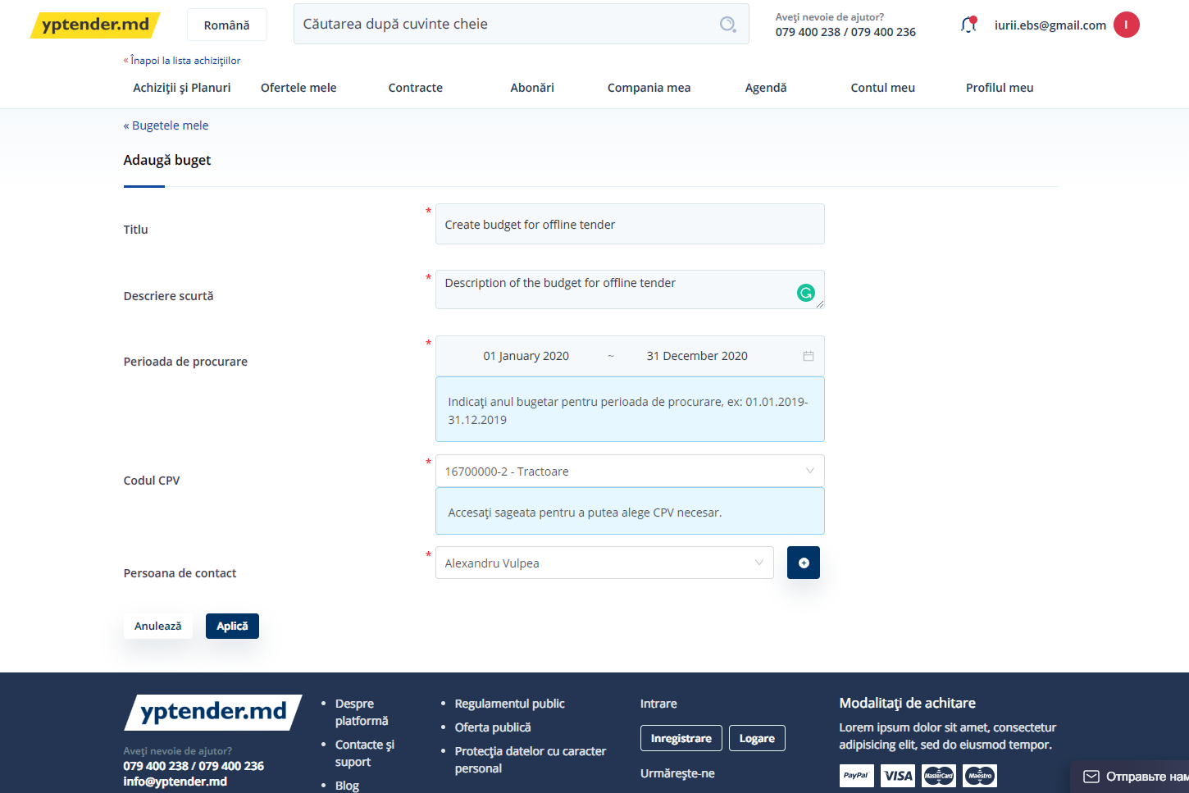

Figure 1. Create budget – Initial data

The user must also select a contact person from the available predefined list, or add a new contact person for this specific procedure:

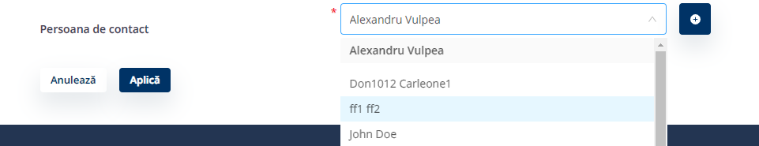

Figure 2. Create budget – Contact person

After providing all of the required data, the user must click on “Apply”. If any of the required data is missing, the System will display a validation error:

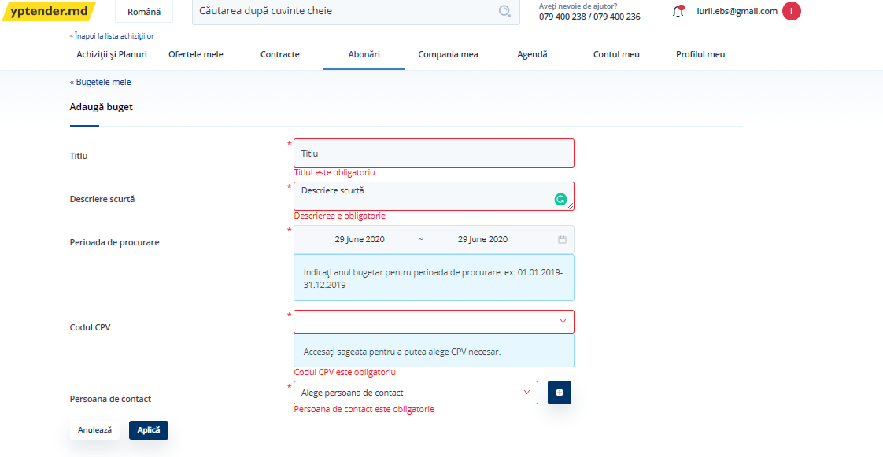

Figure 3. Create budget – Validation error

If data provided by the user meet all requirements of the System, the new budget will be included in the budgets list when clicking on “Apply”.

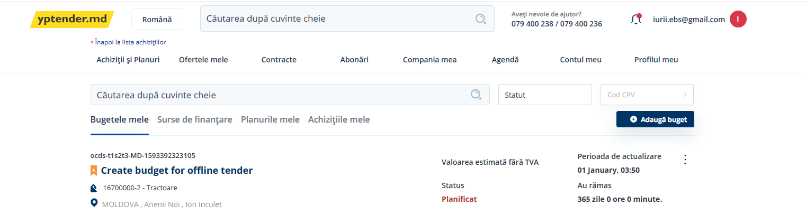

Figure 4. Create budget – New budget added to budgets list

## Add Funding Source

Once the new budget is created, the user will be able to add the funding source by clicking on “Option” button.

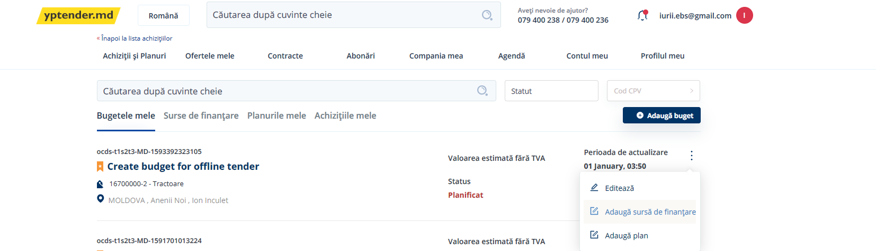

Figure 5. Add funding source

From a legal point of view, the currency of the funding must be indicated in MDL.

Further information must also be provided, taking into account that:

* The Amount of the funding source will be the maximum amount of the purchase;
* the procurement period represents the period when the funding can be spent.

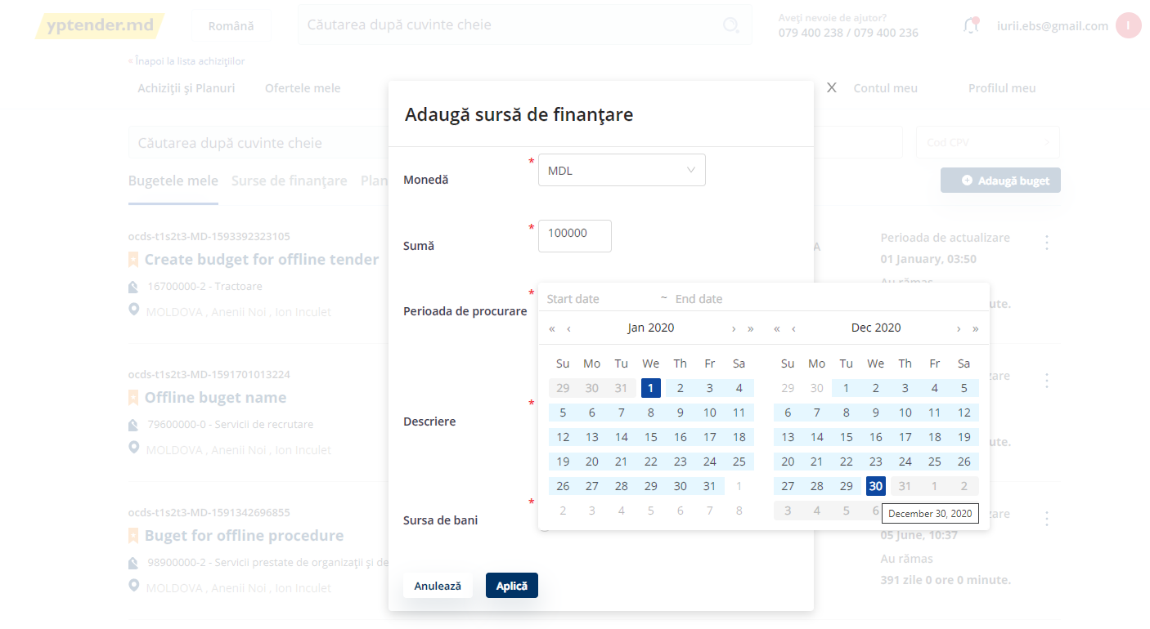

Figure 6. Add funding source –Currency, amount and period

The funding source can be either State budget or CA’s own budget. It can also be funded from the EU; in this case, the user has to tick the check “EU source” and select either the State budget check in case the EU sponsored the State or, otherwise, indicate that the EU sponsored the CA budget directly.

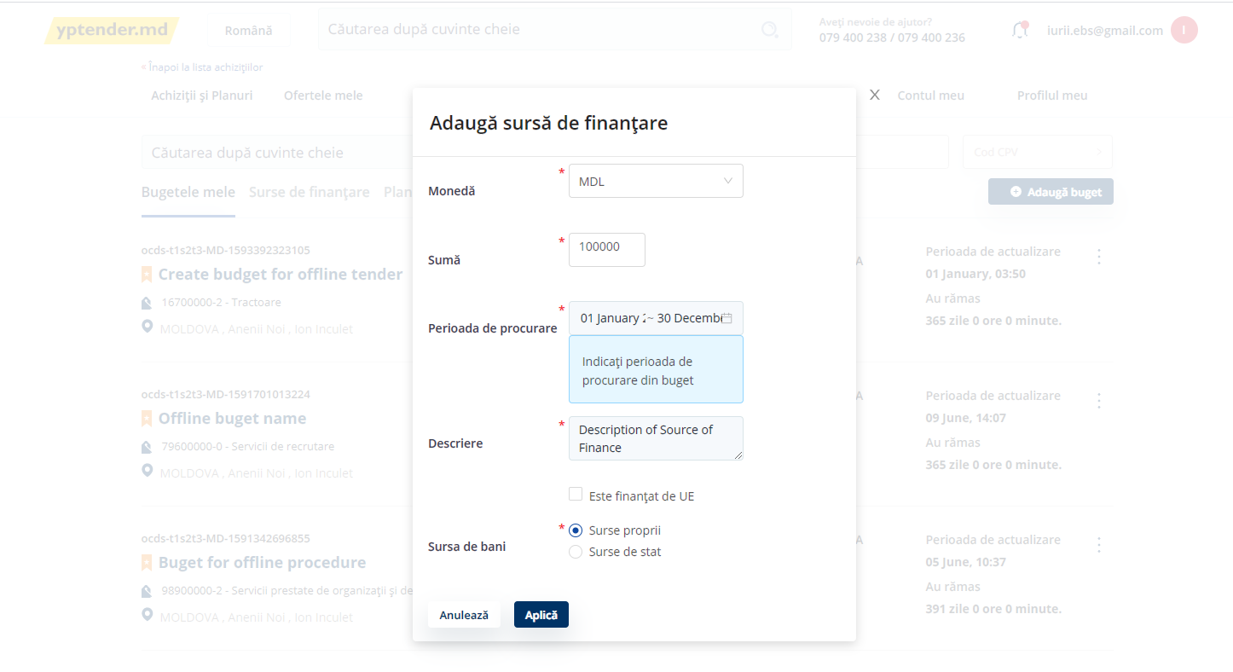

Figure 7. Add funding source – EU funding

After providing all required information, the user must click on “Apply”. If all required fields are properly completed, the added funding source will be included in the funding sources list. Otherwise, the System will display a validation error with the fields that are missing.

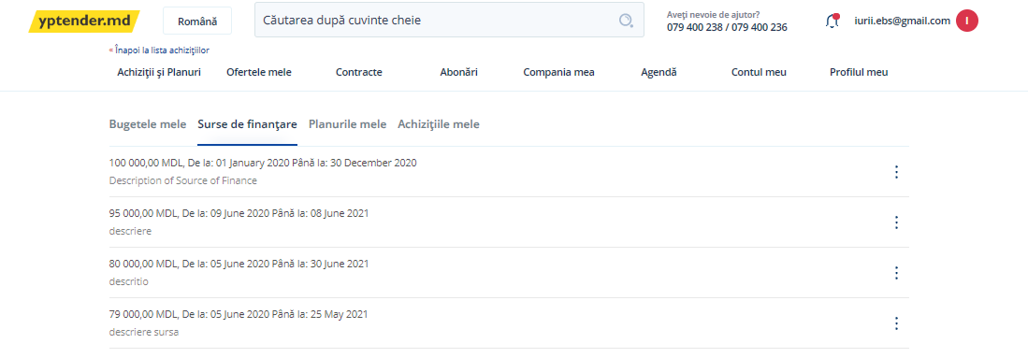

Figure 8. Add funding source – New funding source added to funding sources list

## Create Plan for Offline Procedures

Once the budget is created and it has a funding source, the next step is the creation of the plan for the offline procedure. The user shall select one out of the 3 options available for offline procedures:

* Plan for Negotiation procedure with publication – Negociere cu publicare prealabilă;
* Plan for Negotiation procedure without publication – Negociere fără publicare prealabilă;
* Plan for Direct Award - Achiziție directă de valoare mica.

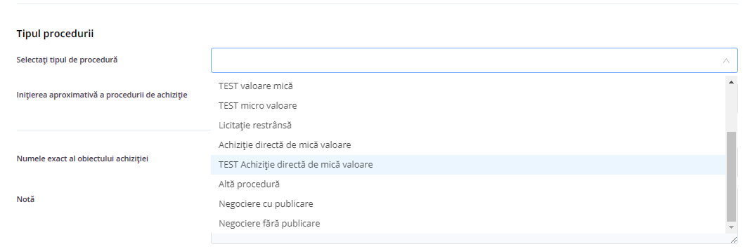

Figure 9. Create Plan for Offline Procedure – Selection of the type of procedure

After that, the user will be required to provide:

* Name of the purchase and note;
* approximate month of purchase initiation;
* funding source.

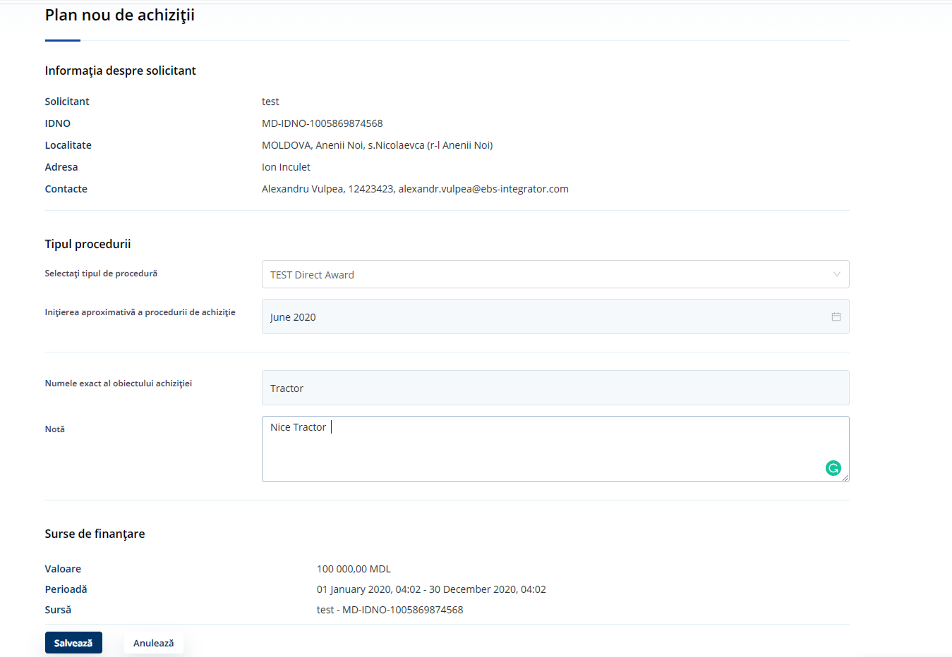

Figure 10. Create Plan for Offline Procedure – Information required

When all required data is provided, the user shall click on “Save” and the new plan will be added into the Plans list, with status “Active”.

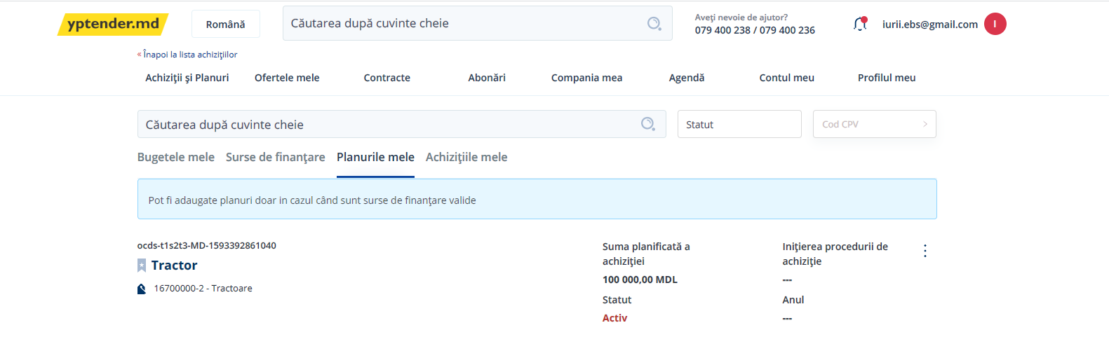

Figure 11. Create Plan for Offline Procedure – New active plan added to plans list

## Update Plan for Offline Procedures

In order to update the Plan, the CA must follow the next steps:

* Access “My Plans” tab and click on “Edit”:

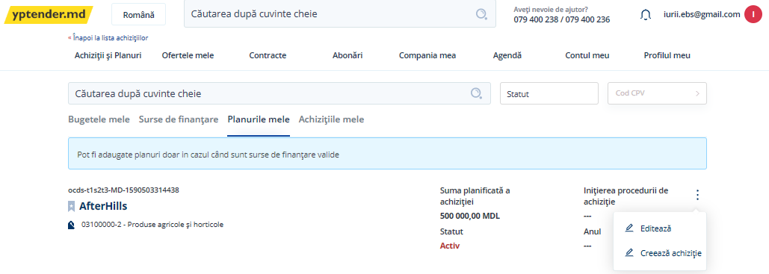

Figure 12. Update Plan for Offline Procedure – Edition of the plan

* Update the necessary information (Name of the purchase and note, month of purchase initiation):

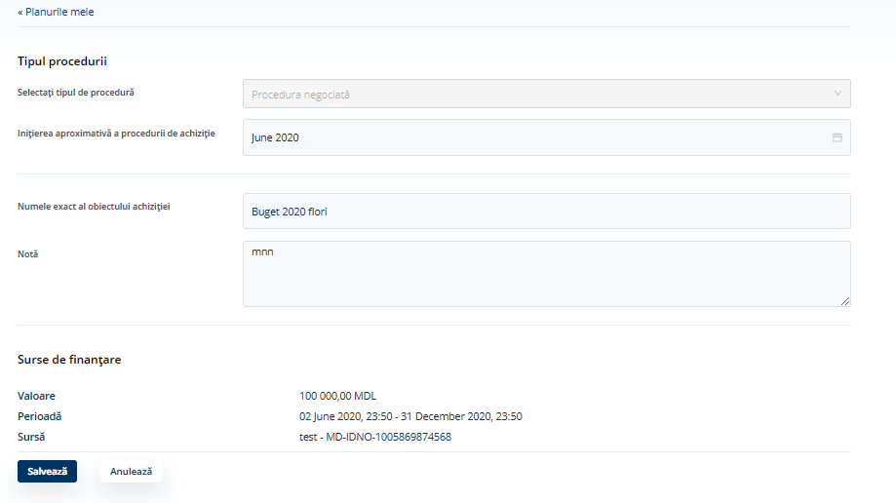

Figure 13. Update Plan for Offline Procedure – Update Plan information

## Create Offline Tenders

Once the plan is available with status “Active”, offline tenders can be created in the System by clicking on the “Option” button:

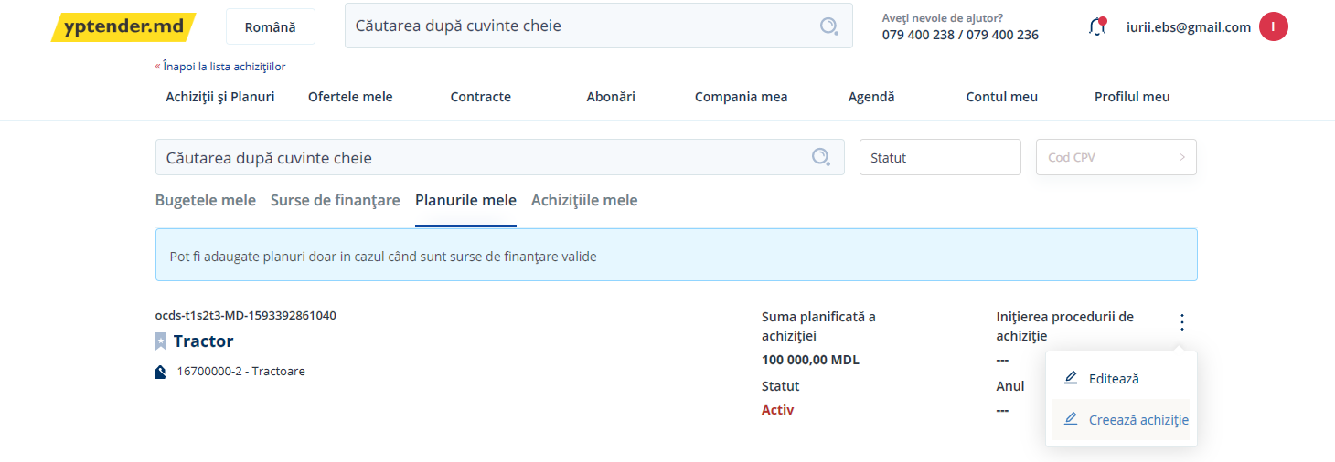

Figure 14. Create offline tender – Options

The user shall: (1) Complete the tender form; and (2) upload the documents of the tender and select the type of documents.

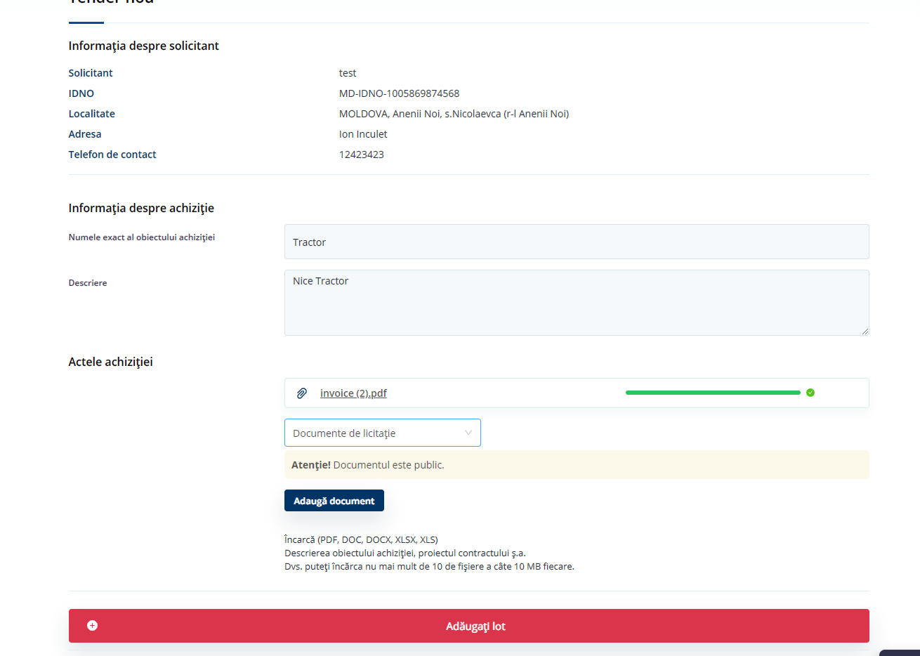

Figure 15. Create offline tender –Create a tender in the System

## Create Lots

When a procurement procedure is divided into lots, information of the lots shall be provided.

In order to create a lot in the System, the user shall provide:

* Name of the lot;
* description of the lot;
* value of the items, which cannot be higher than the amounts provided in the CA’s Plan;
* contract period and address.

Once a lot is created, the user will be able to add items to it (see the next section of this document).

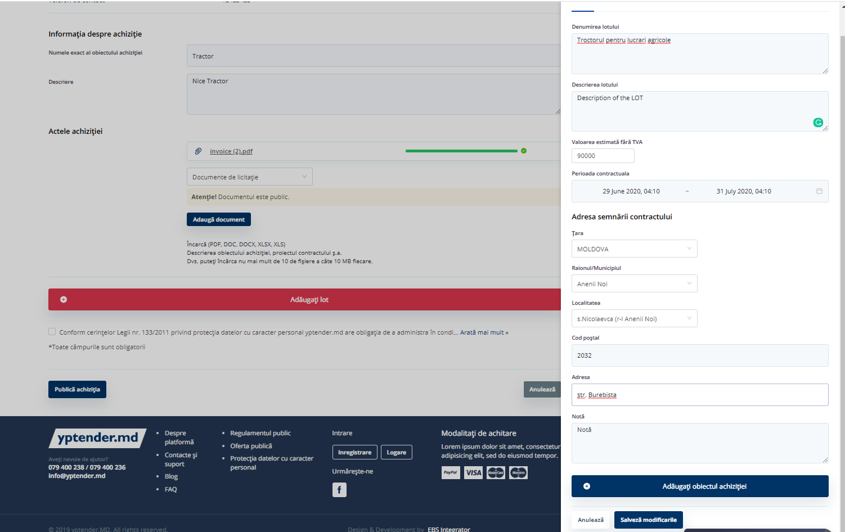

Figure 16. Create lot – Lot information

## Add Items to a Lot

Each lot can contain a single or several items.

In order to add items to a lot, the user shall click on “Add item” and:

* Provide a description of the item;
* select a CPV code from a predefined list;
* provide a quantity, unit and measure type for the item.

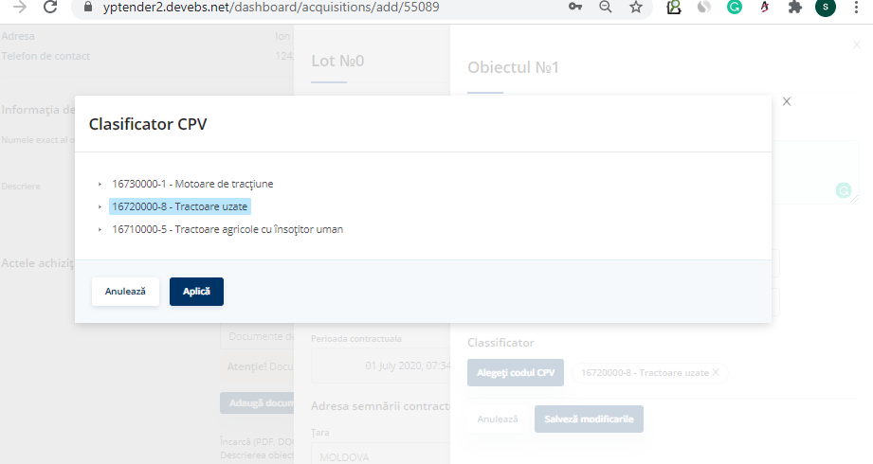

Figure 17. Add item to a lot – Selection of a CPV code

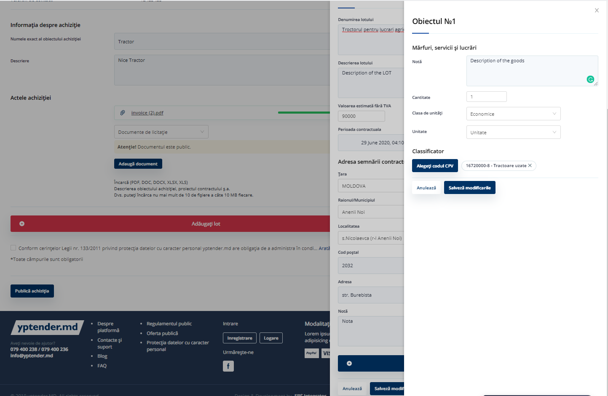

Figure 18. Add item to a lot – Description of the item

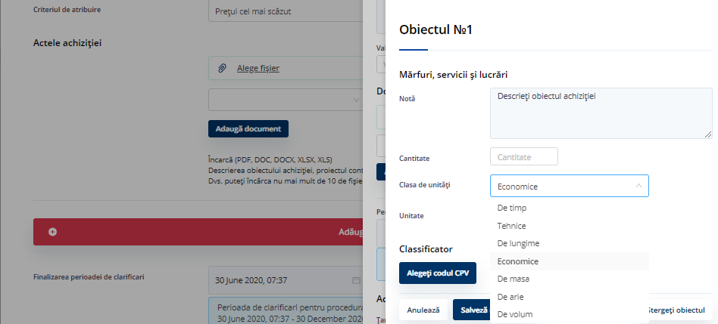

Figure 19. Add item to a lot – Quantity, unit and measure type for the item

Once all items have been added to lots, the user has to click on “Save”.

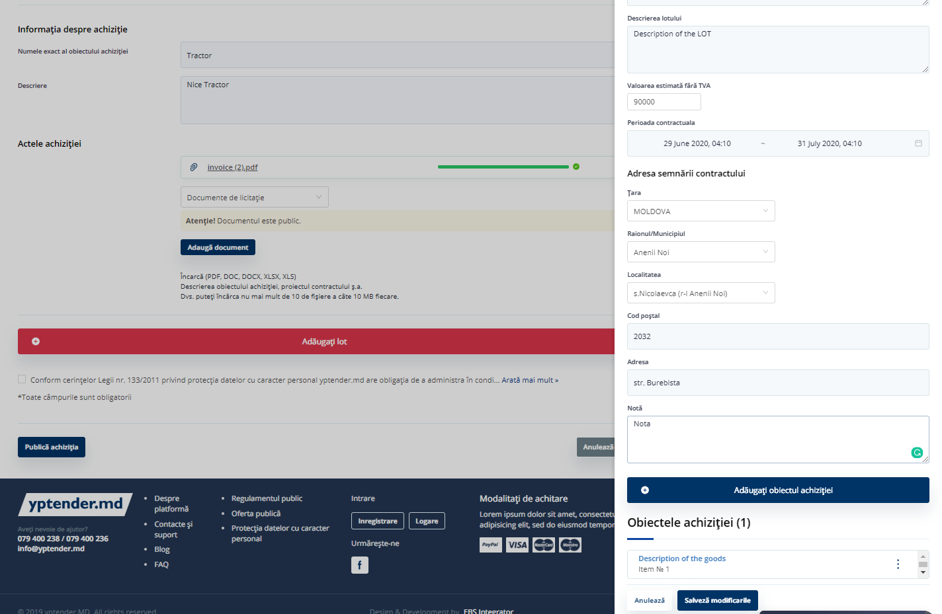

Figure 20. Add item to a lot – Save information

Once the tender is saved, it will be displayed in “My purchases” list and the user will be able to add participants to the tender.

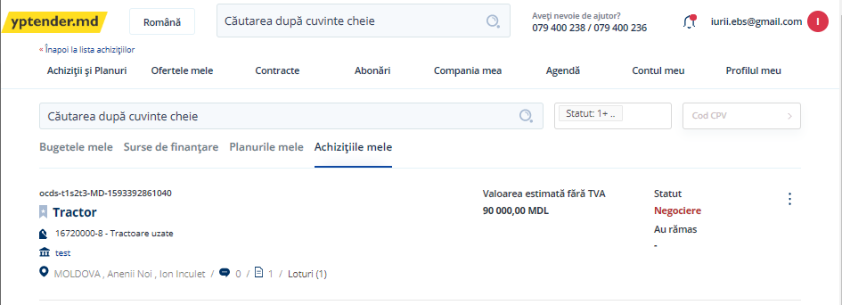

Figure 21. Add item to a lot –New tender added to “My purchases” list

* 1. Cancel a Tender

The user can cancel a tender following these steps:

* From “My purchases” tab, open the tender that requires cancellation. The system will display

all tender details, including tender periods, status, procurement method, etc.;

* click on “Cancel”.

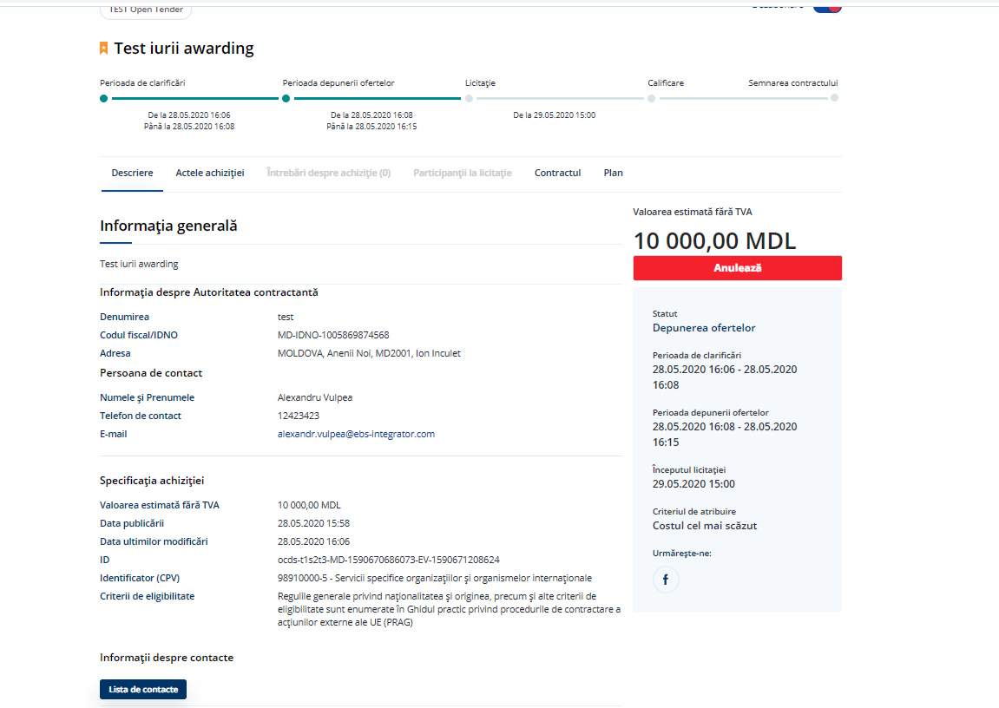

Figure 22. Cancel a tender – Detail of the tender

In order to cancel a tender, the user must fill in a form in a pop-up providing:

* A reason for the cancellation of the tender and a description of the reason;
* a cancellation document (that the user needs to upload);
* a document type from a predefined list.

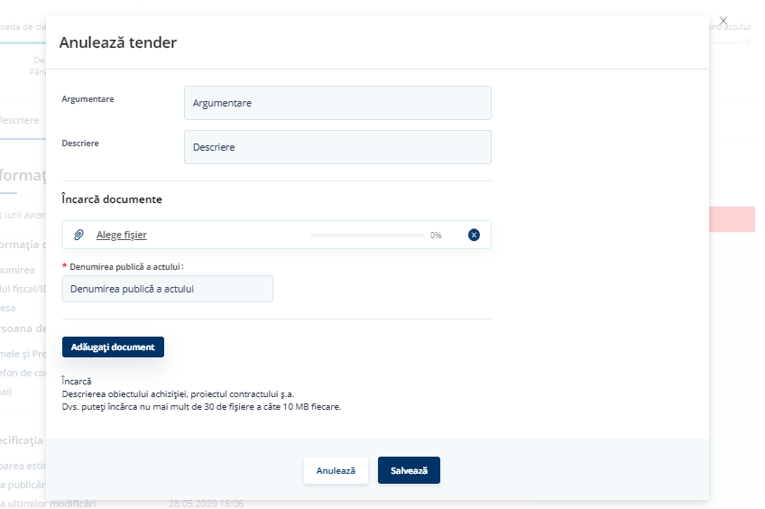

Figure 23. Cancel a tender – Cancelation form

Once the required information is properly filled in, the user shall click on “Save”. The status of the tender will switch to “Cancelled”.

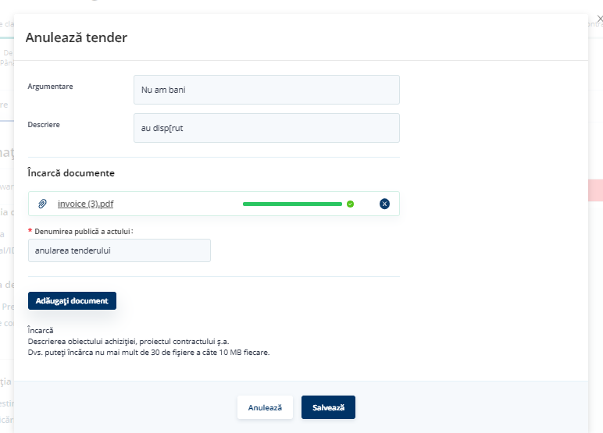

Figure 24. Cancel a tender – Save cancelation

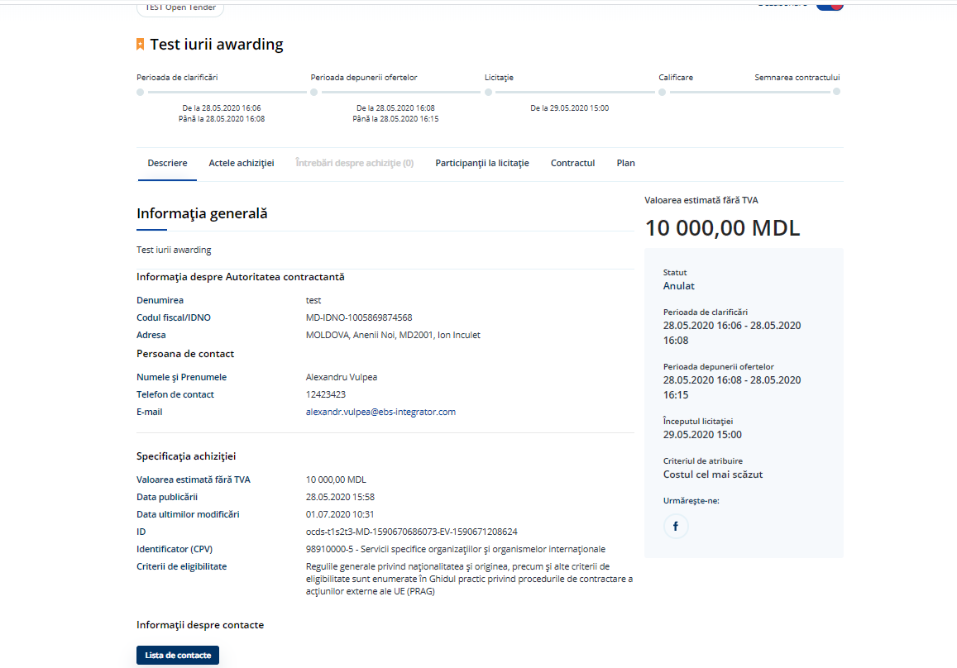

Figure 25. Cancel a tender – Status updated to “Cancelled”

The new status of the tender will also be displayed in the list of tenders:

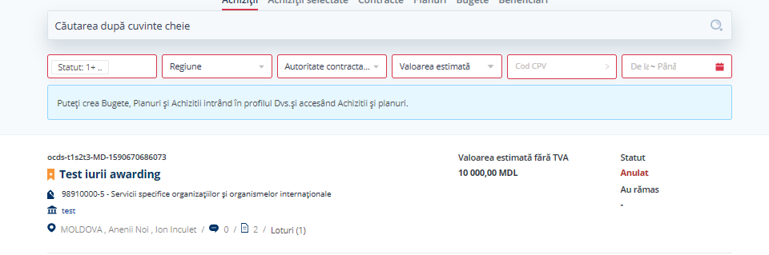

Figure 26. Cancel tender - Tenders list

## Negotiation without publication. Add participants

For the procedure Negotiation without publication, which is partially conducted out of the System, the CA needs to create tenderers one by one. The CA has to provide all the information about each tenderer. In this particular procedure, tenderers are added at the final step, and a decision shall be taken on each tenderer before proceeding to create another one.

The CA must provide information about the EOs participating in the procedure following these steps:

* Access ”My purchases” list;
* select a tender and click on “Options”;
* once within the selected tender, click on ”Participanți”.

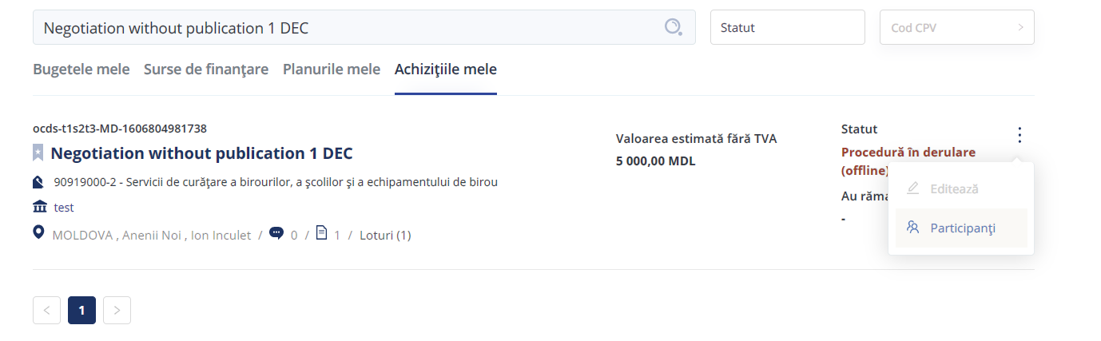

Figure 27. Add participants

When the procurement procedure is divided into lots, the user shall indicate to which lots the tenderer must be added.

Information about the tender (amount and currency) and a description of the tenderer must be provided.

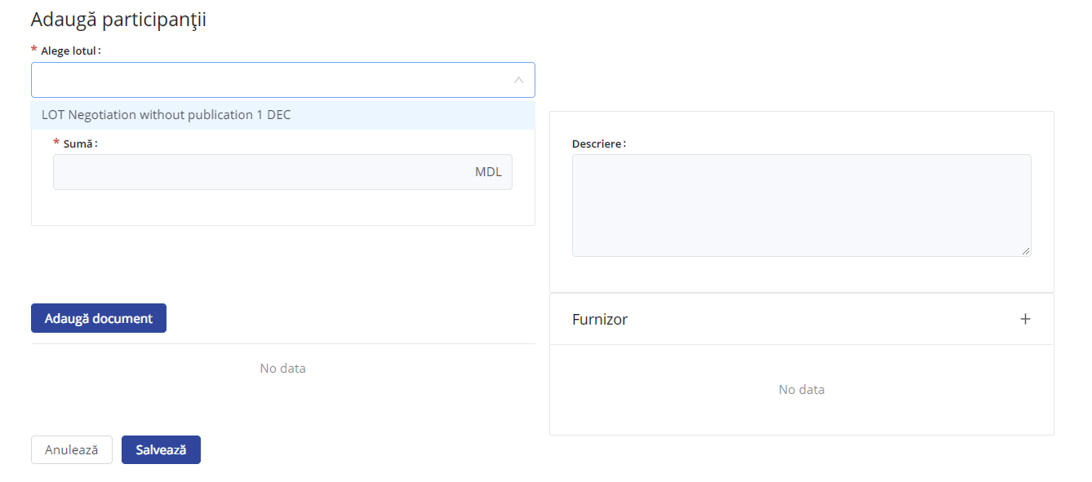

Figure 28. Add participants – Tender information

The user will be required to provide information (data and documents) about the tenderer:

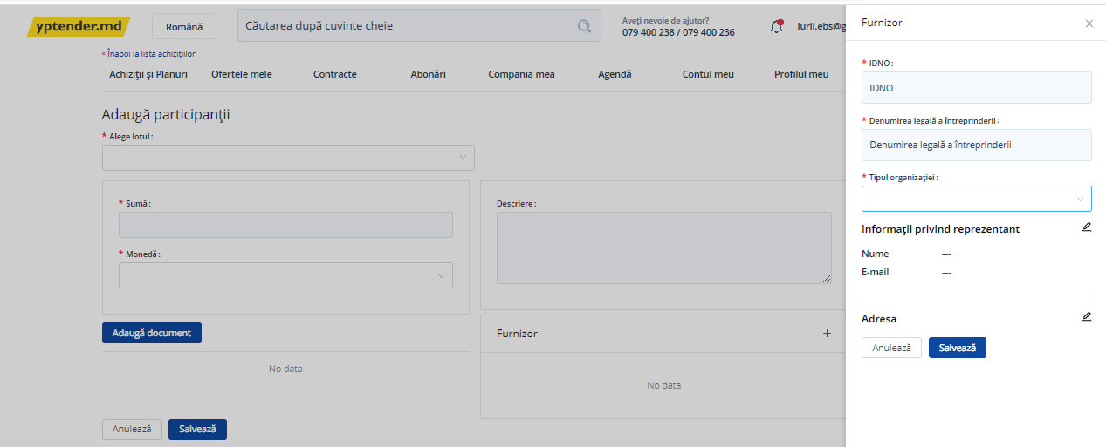

Figure 29. Add participants – Tenderer information

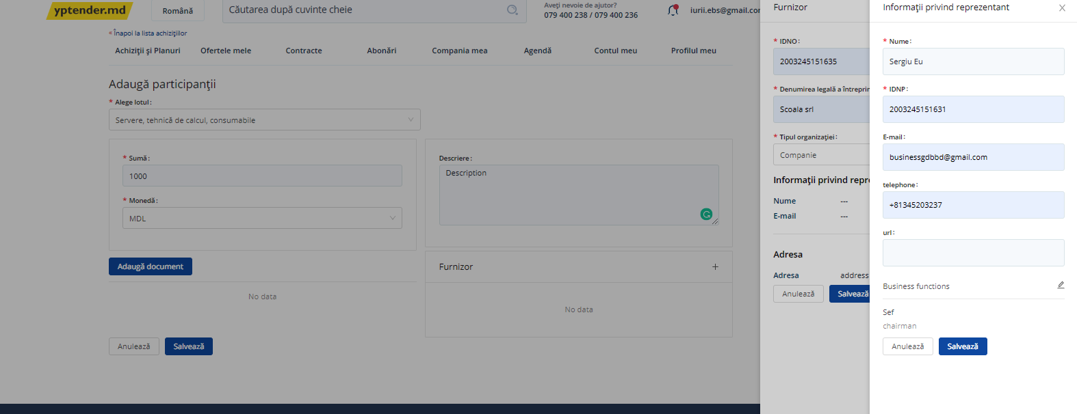

Figure 30. Add participants – Tenderer information

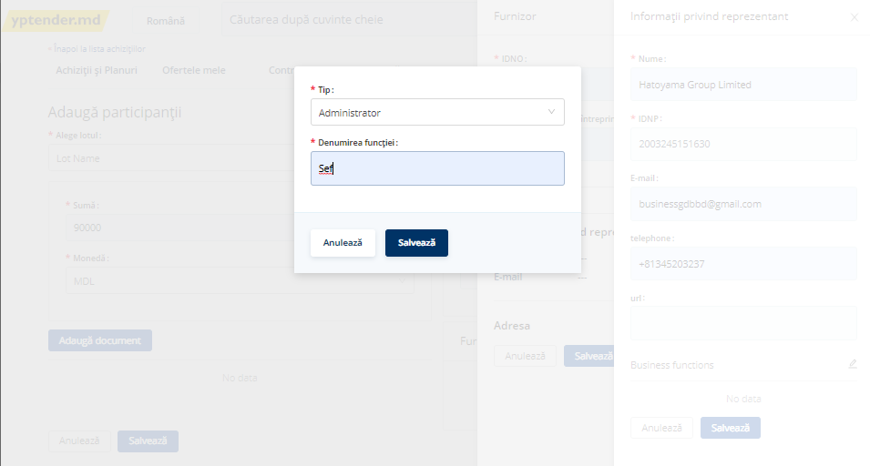

Figure 31. Add participants – Tenderer information

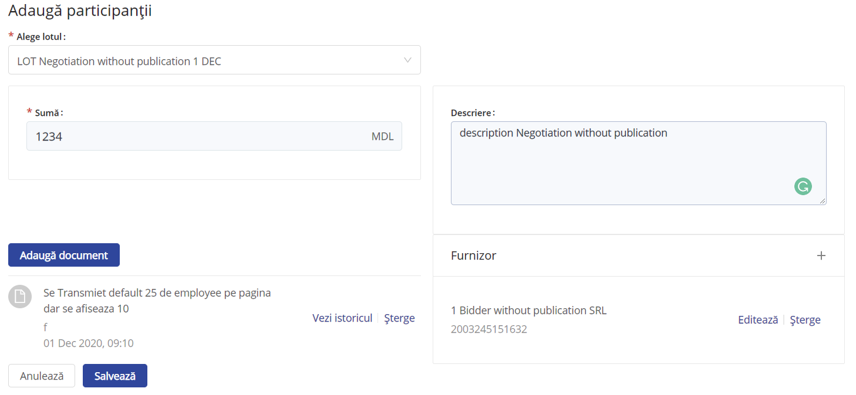

Figure 32. Add participants – Tenderer information

When all information about the tenderer is completed, the user shall click on “Save”.

After adding the tender, it will be displayed in Participant’s tab:

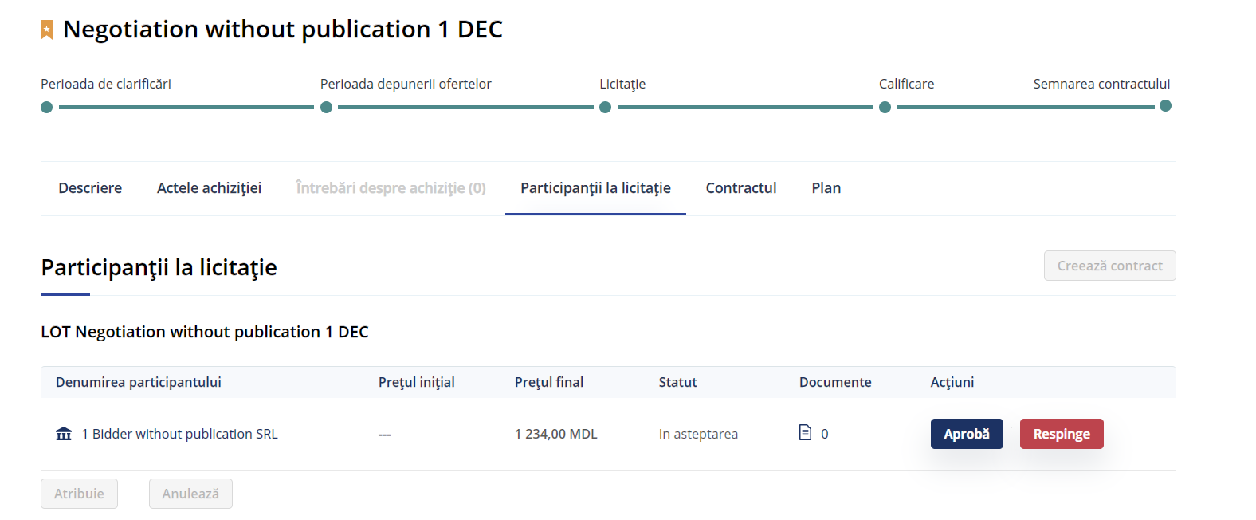

Figure 33. Add participants – Tenderer added

It is necessary that the CA indicates a decision regarding the tenderer added in order to be able to add more tenderers to the same lot:

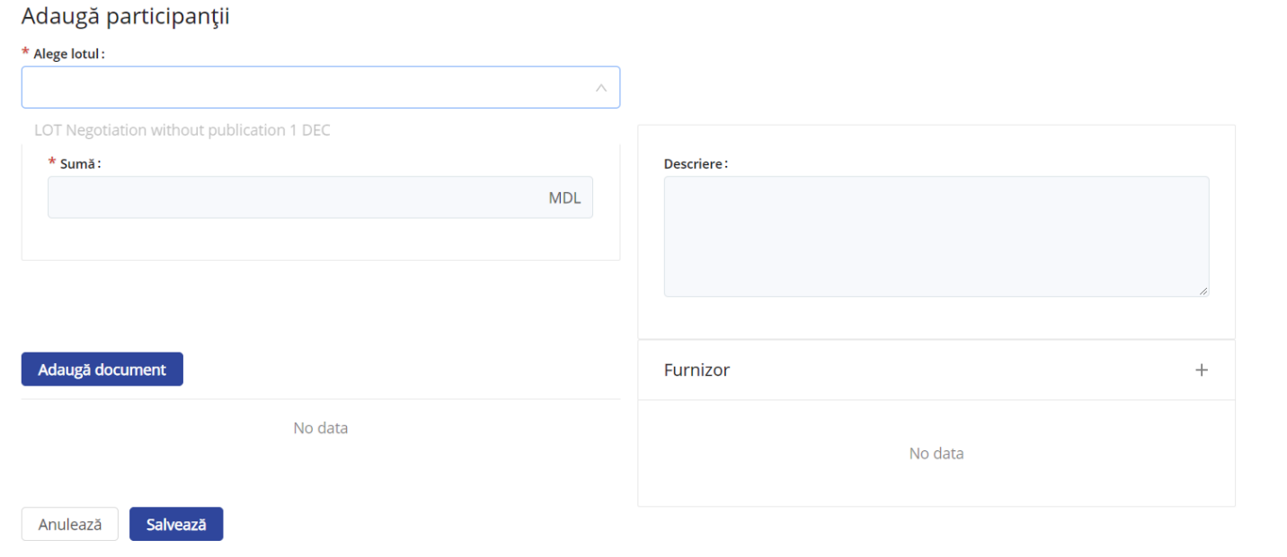

Figure 34. Add participants – Only a single active bidder is allowed

## Negotiation without publication. Making a decision

When the first tenderer has been added, the CA has to indicate the decision taken on it. In order to do this, the CA shall access Participant’s tab:



Figure 35. Making a decision –Participant’s tab with the first tenderer

While the CA reviews the tenderer, it is displayed with status “în așteptare - waiting”, which indicates that it is pending the decision of the CA. At this point, the CA can reject the tender:

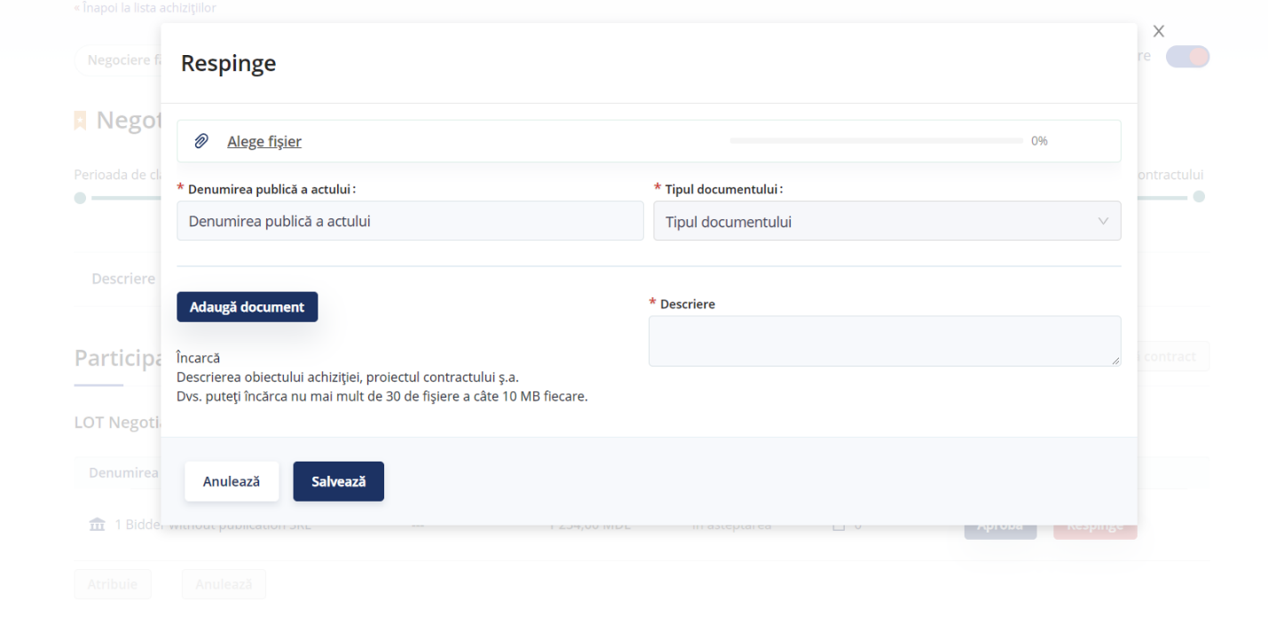

Figure 36. Making a decision – Rejection of a tenderer

When rejecting a tenderer, the CA will be requested to provide a document and to describe the reason for rejection.

Once rejected, the status of the tenderer will switch to “rejected” and the CA will be able to add the next tenderer to the lot.

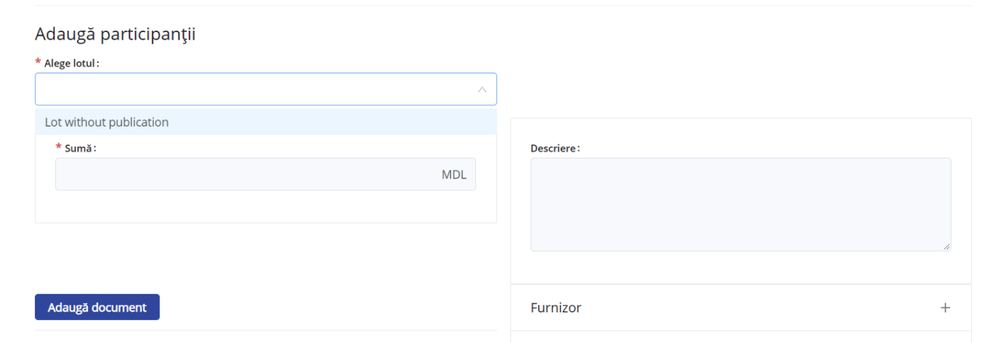

Figure 37. Making a decision – Creation of the next tenderer after rejection of the previous one

If the tenderer fits all requirements, it can be selected as the winner. In order to do so, the CA must press “Approve” button:

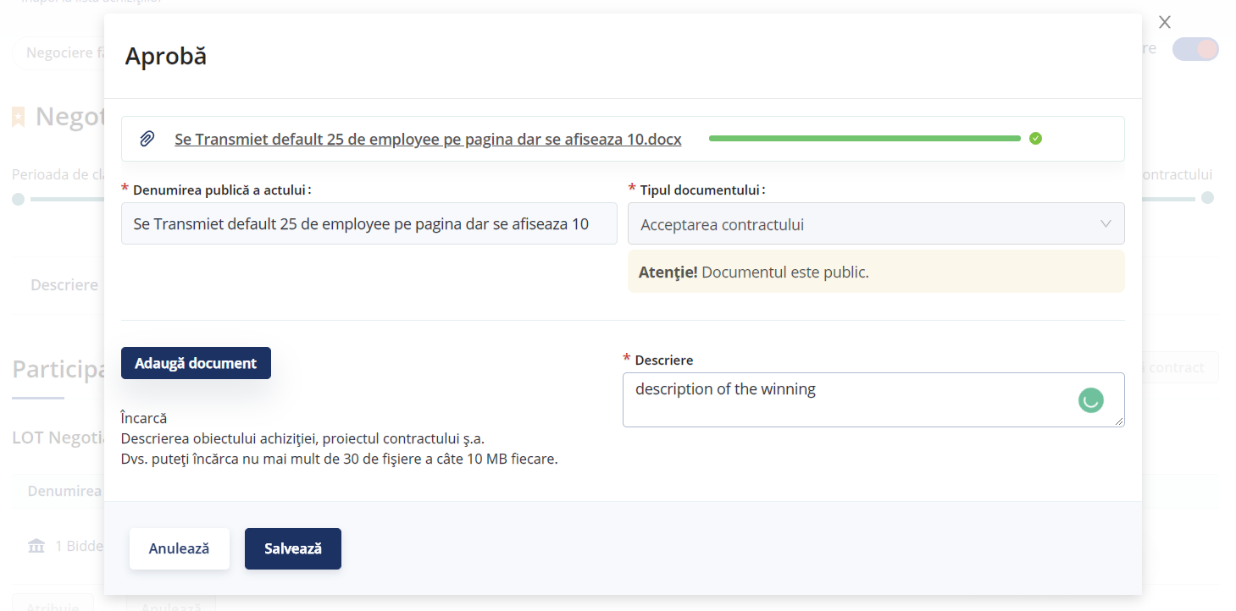

Figure 38. Making a decision – Selection of the winner

When the CA sets the winner, the status of the tender will switch to “Approved - aprobat”, and the CA will be able to assign the winner:

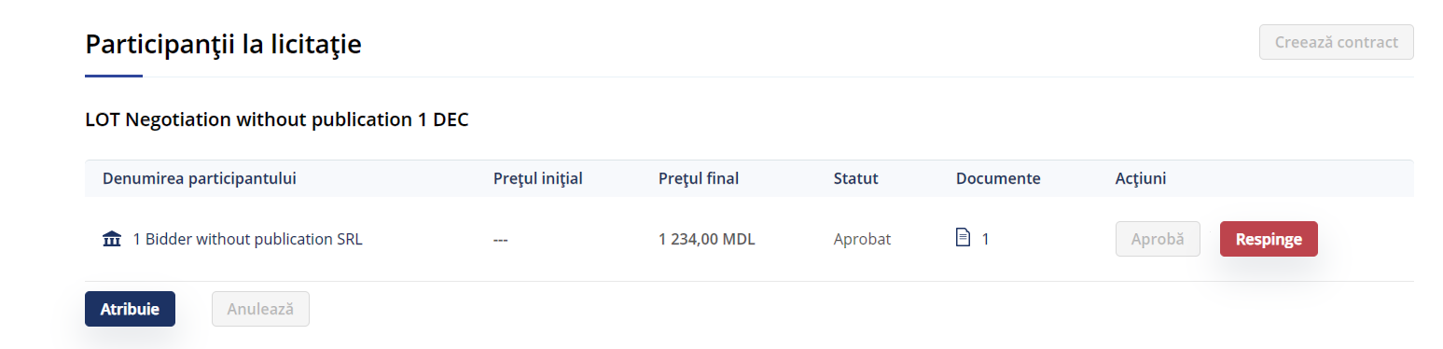

Figure 39. Making a decision –Winner selected, status “Approved” allows the assignment of the winner

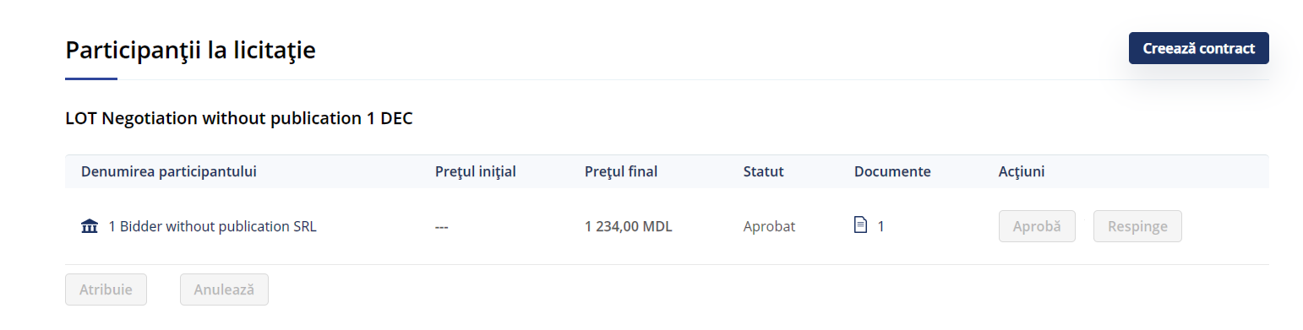

Figure 40. Making a decision –Winner assigned, the status allows the creation of the contract

Once the winner is selected and assigned, functionality “Create contract” will be available.

(*NOTE:* Creation of the contract is not implemented).

## Negotiation with publication. Add tenderer

In a Negotiation with publication procedure, the CA needs to create the (offline) tender and, once created, will be able to add the tenderers. In order to do so, it is necessary to:

* Access ”My purchasing” list;
* select a tender and click on “Options”;
* once within the selected tender, click on ”Ofertanți”.

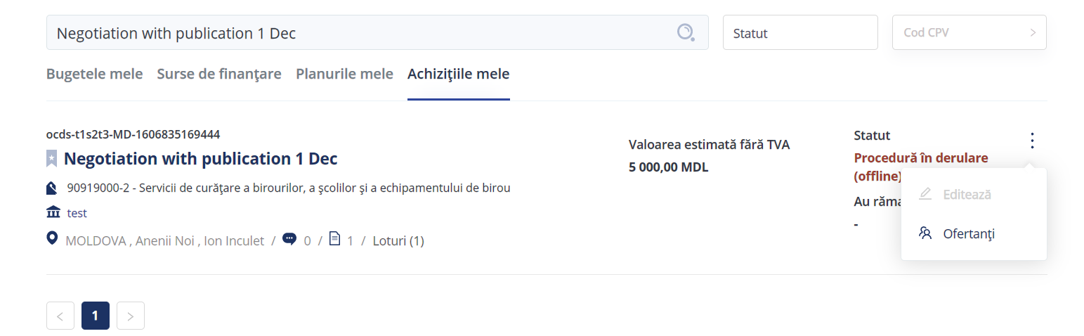

Figure 41. Add tenderer – Adding tenderers once the tender is created

Initially, the CA is required to provide all the required information about the tenderer and also the tender amount.

It is necessary to choose the lot:

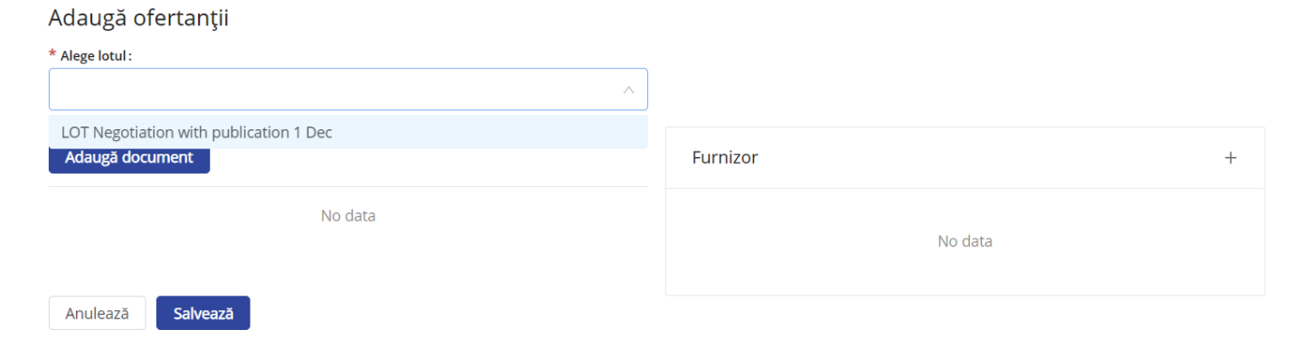

Figure 42. Add tenderer – Selection of lot

Once the lot is selected, the CA must provide all requested tenderer information:

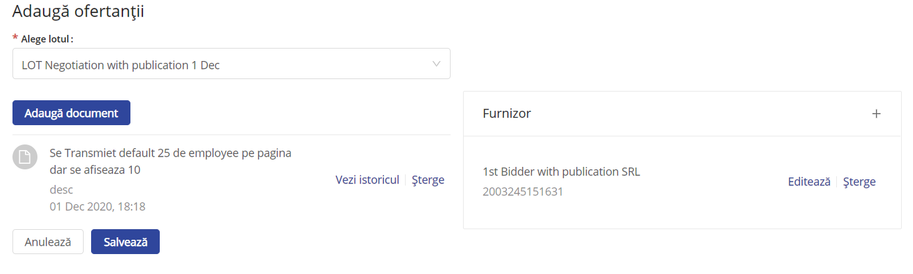

Figure 43. Add tenderer – Tenderer information

The tenderers added to the lot by the CA will have initial status “waiting - în așteptare”. At this moment of the procedure, the CA negotiates with all of the tenderers and, after receiving the final offers and evaluating them, the CA will proceed to make a decision.

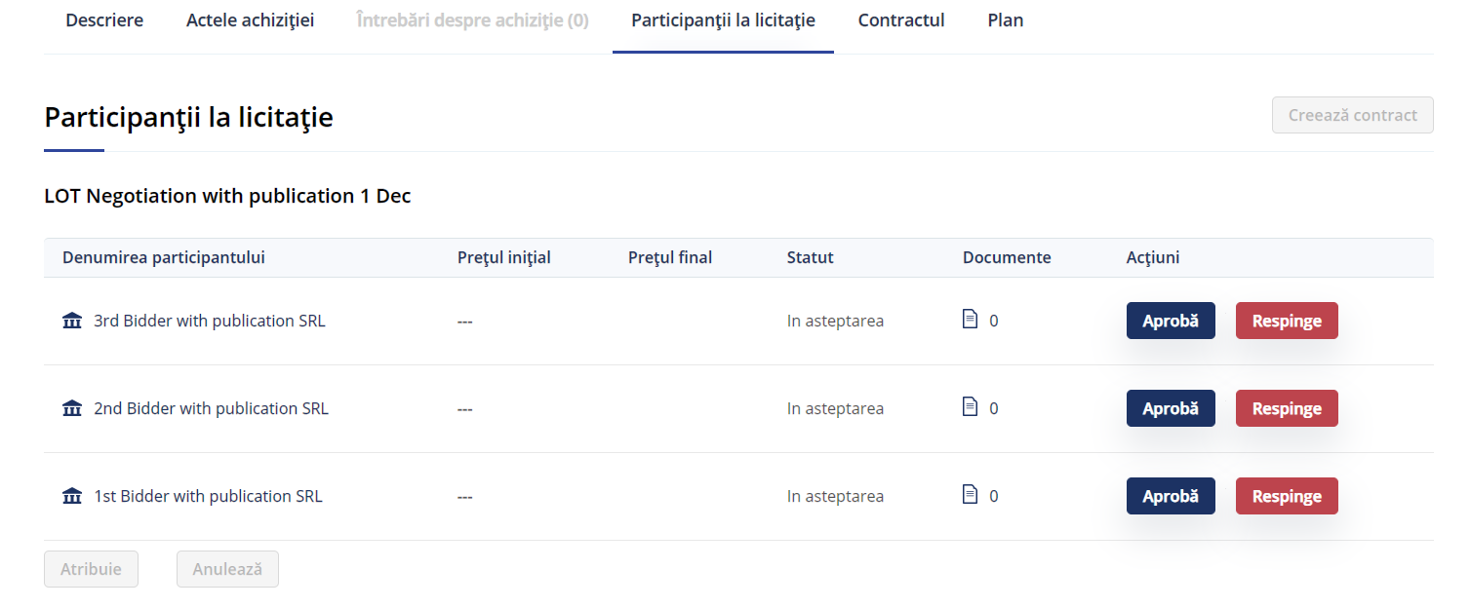

Figure 44. Add tenderer – List of tenderers added to a lot

## Negotiation with publication. Making a decision

After negotiation and evaluation of final offers, the CA will take a decision.



Figure 45. Making a decision – List of tenderers on which the CA can make a decision

The CA can either approve or reject the tenderer. Only one tenderer can be approved. In order to approve a tenderer and, therefore select it as the winner, the CA has to fill all required information and the final amount offered by the winning tenderer.

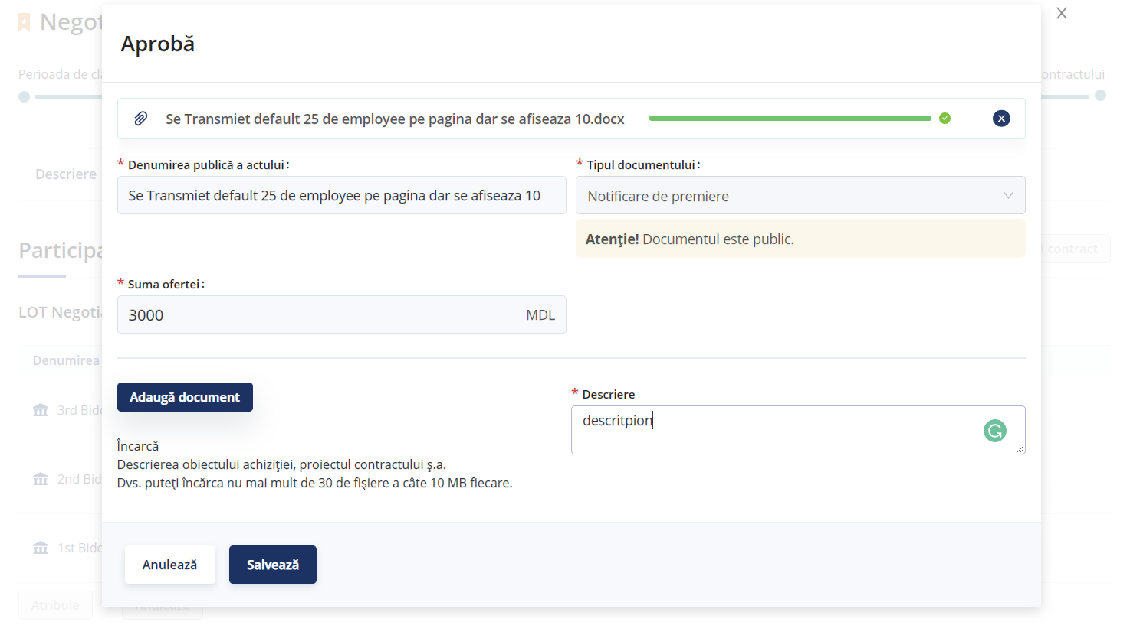

Figure 46. Making a decision – Approving a tenderer (selection of the winner)

The winning tender status will switch to “approved - aprobat”:

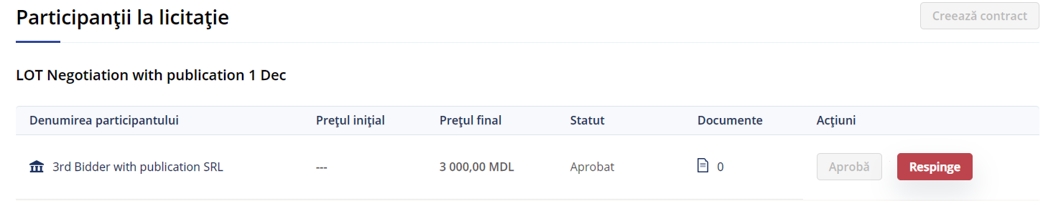

Figure 47. Making a decision – Status of the winning tenderer

In worder to make the assignment, the CA has to reject all the tenderers that were not selected after the negotiation. For each of them, a documents of rejection, the reason of rejection and the final amount of the offer are required.

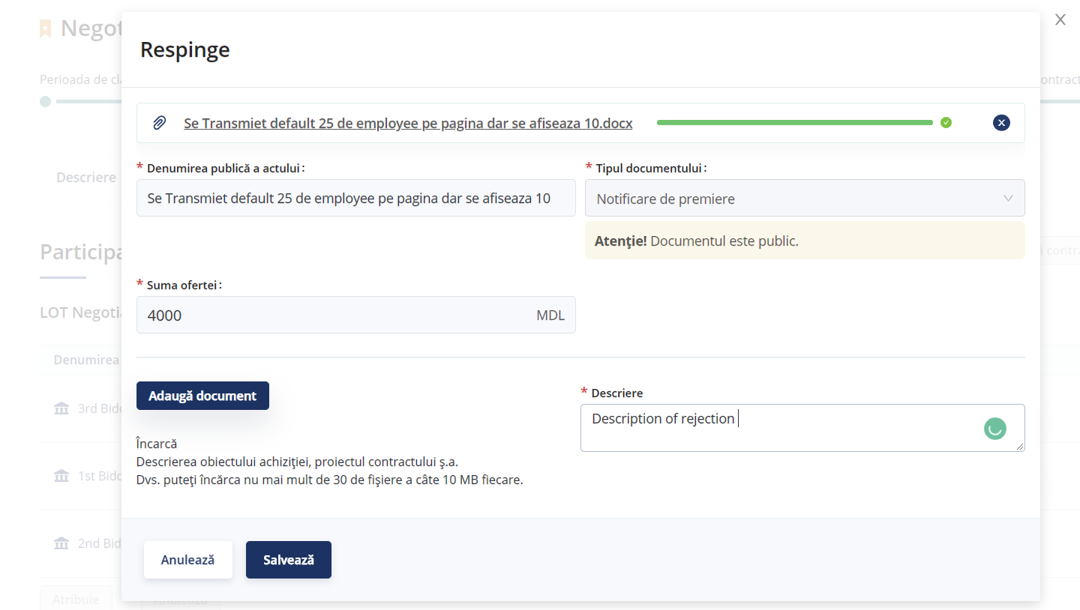

Figure 48. Making a decision – Rejection of a tenderer

The rejected tenderers status will switch to ”rejected- fără succes”:



Figure 49. Making a decision – Status of the rejected tenderers

When all tenderers have their final status and one of them has been approved (selected as the winning tenderer), the CA can assign the winner:

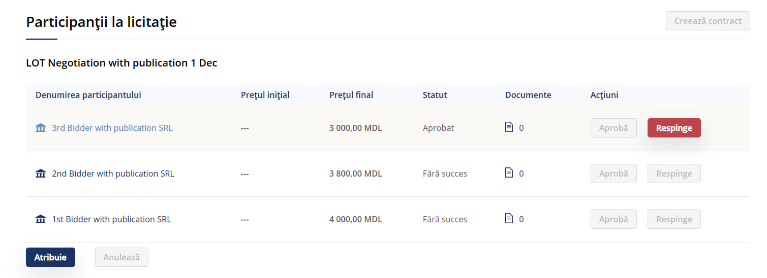

Figure 50. Making a decision – Assignation of the winner

After the winner is selected, the CA shall click on “assign - atribuie” in order to make functionality “Create contract” available.

(*NOTE*: Creation of the contract is not implemented).

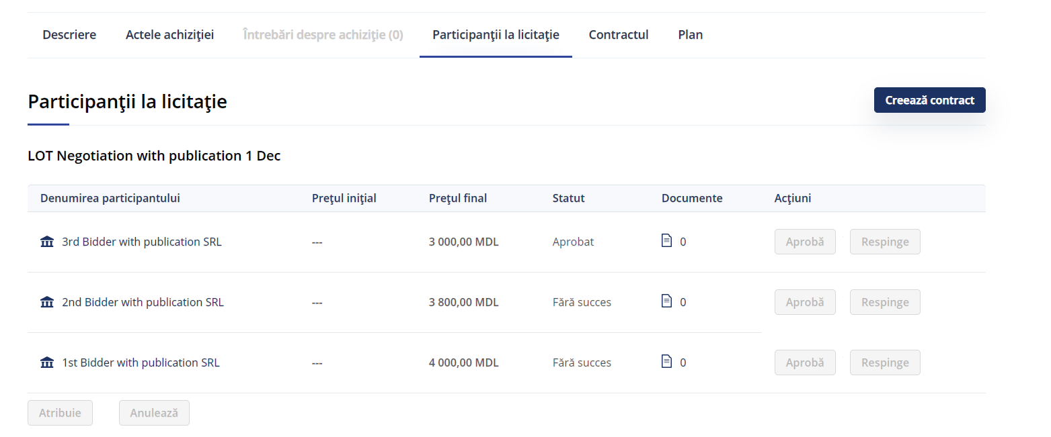

Figure 51. Making a decision – Creation of the contract

## Direct award. Adding the winner

In a Direct award procedure (Achiziție directă de mică valoare), once the tender is created in the System, the CA is able add the winning EO. In order to add the winner, the CA needs to:

* Access “My purchasing” list;
* select a tender and click on “Options”;
* once within the selected tender, click on ”Câștigărot”.

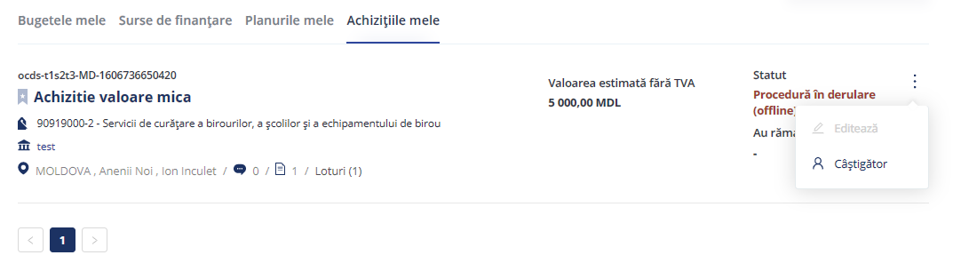

Figure 52. Adding the winner

When the tender is divided into lots, the user shall indicate the winner for each lot.

Information about the offer (amount) and a description of the winner must be provided.

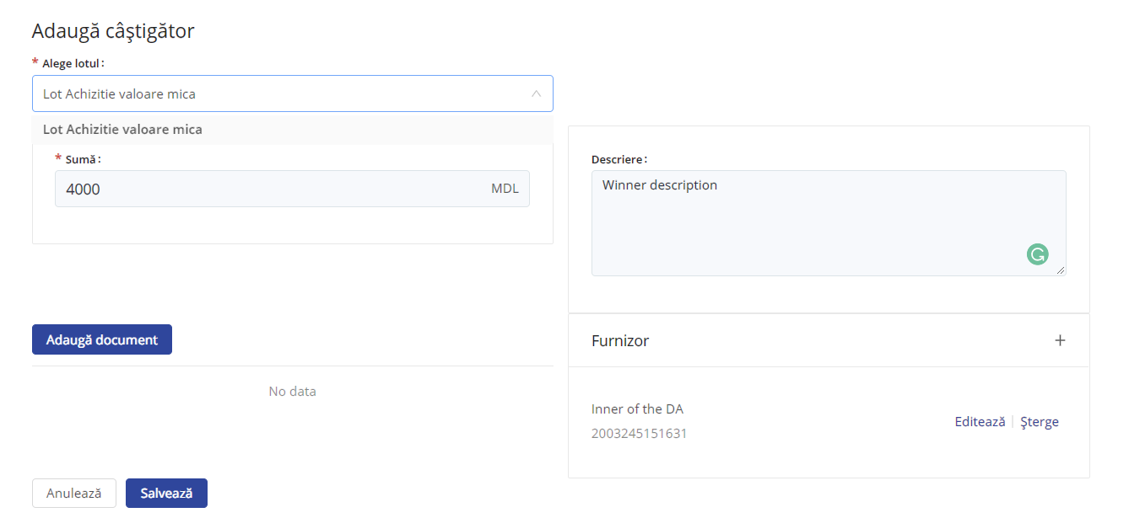

Figure 53. Adding the winner –Required information

The CA will be required to provide information (data and documents) about the winner:

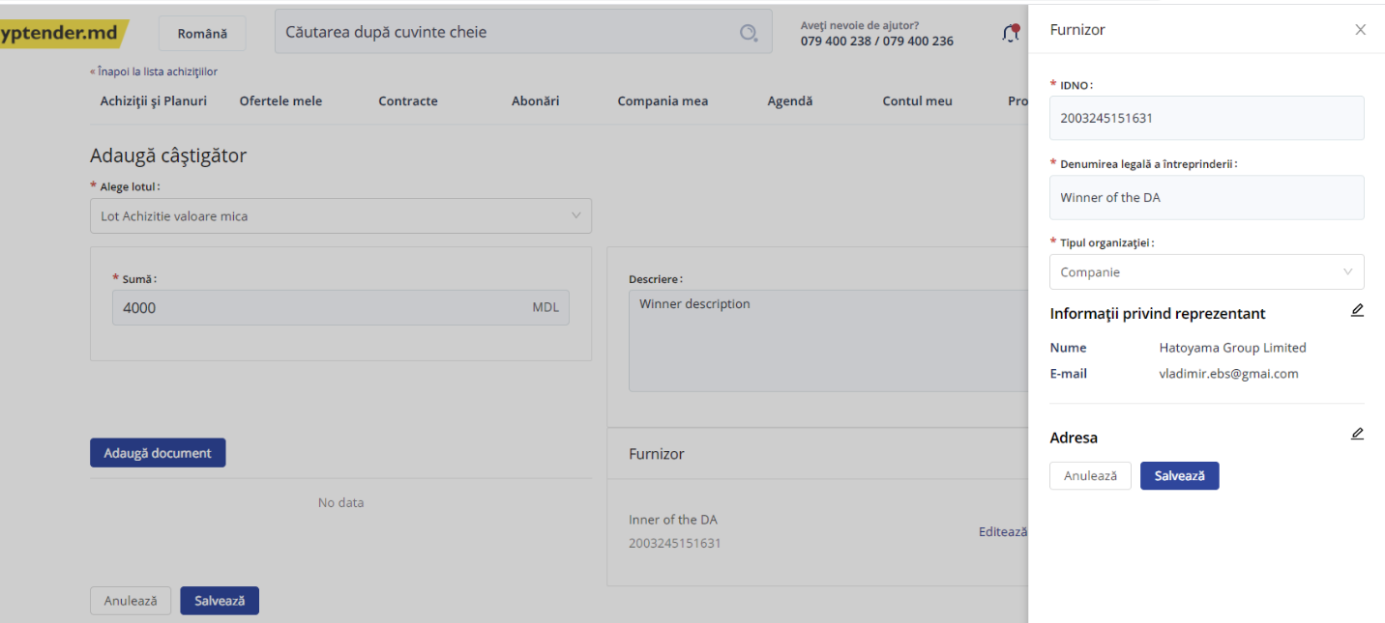

Figure 54. Adding the winner –Required information



Figure 55. Adding the winner –Required information



Figure 56. Adding the winner –Required information

Once all required information is provided, the user must click on “Save”.

Once the winner is added, the functionality “Create contract” will be available.

(*NOTE:* Creation of the contract is not implemented).

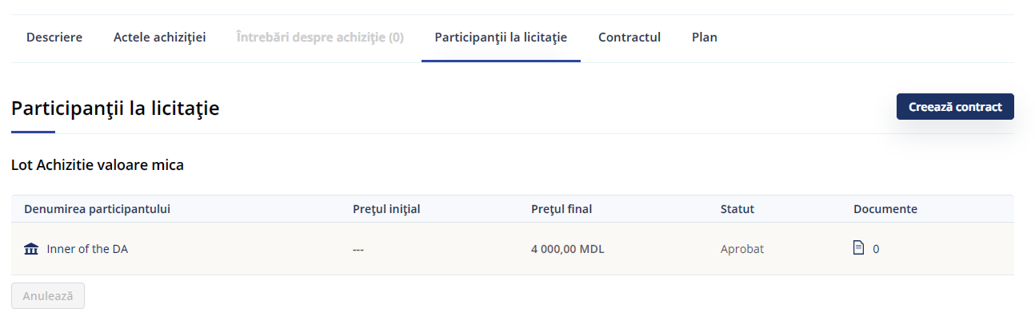

Figure 57. Adding the winner –Creation of the contract

# Procurement procedures fully conducted within the system

In order to create an online tender, the user needs to create a budget (see section 2.1 of this document) and add a funding source to the budget (see section 2.2 of this document).

Once these steps are completed, the user is able to conduct the actions described in the following sections.

## Create the plan for Online Procedure

Once the budget is created and the funding source has been added, it is necessary to create a plan for the online procedure. In order to do so, the user shall select one of the options available for online procedures:

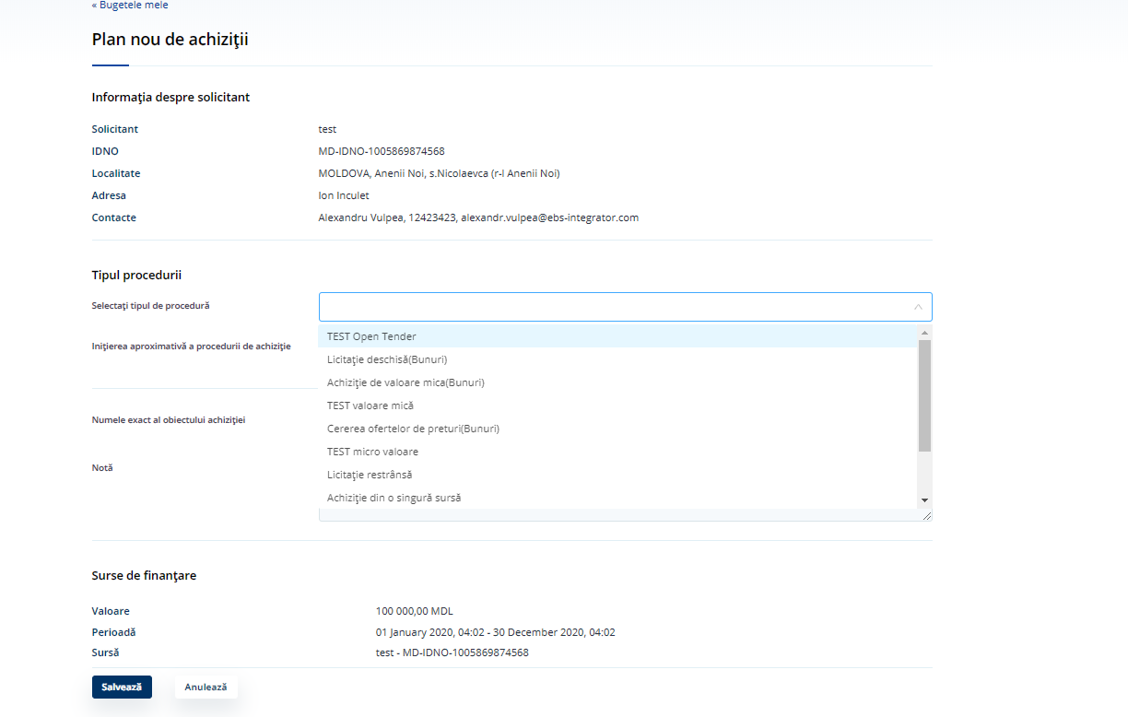

Figure 58. Create the plan for online procedure – Select the procedure type

After that, the user will be required to provide:

* Name of the purchase and note;
* approximate month of purchase initiation;
* funding source.



Figure 59. Create the plan for online procedure – Name of the purchase and note

When all required information is provided, the user shall click on “Save” and the new plan will be created in the Plans list, with status “Active”.

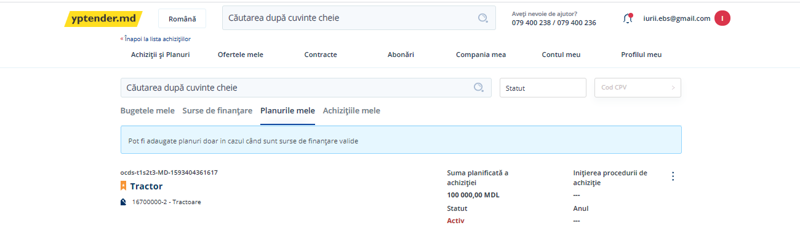

Figure 60. Create the plan for online procedure – Save the plan

* 1. Create Online Tender

In order to create an online tender, a budget and a plan for this tender are required, as detailed in sections above.

On “My plans” tab, the user can see all the plans available, select one and, using the options button, click on “Add purchase”. The System will open a tender form.

In this tender form, the user will be required to provide some data (Name of the procurement procedure and description of the needs) and to upload the tenders’ documentation.

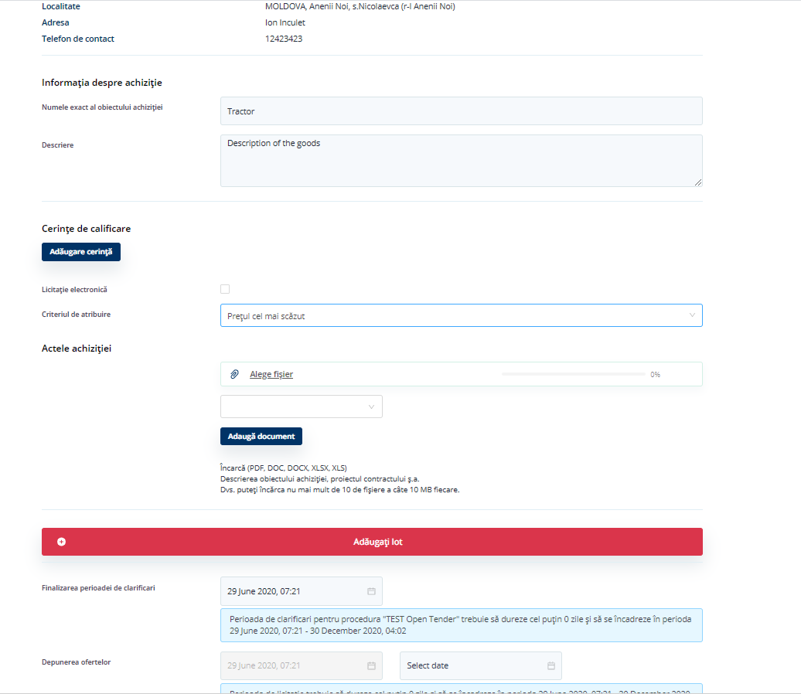

Figure 61. Create online tender – Tender general information

Depending on the selected procurement method, the user might be required to add Awarding Criteria (price-only method does not require award criteria).

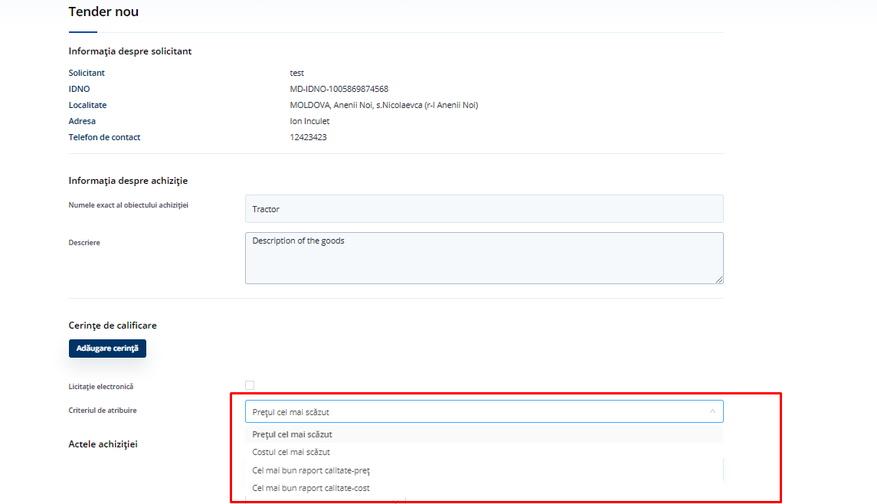

Figure 62. Create online tender – Selection of the procurement method

The user will be able to introduce qualification requirements clicking on “Add requirements”. The name and description on the group of requirements will be required, and the button “Add requirement” will allow the creation of new requirement in a pop-up.

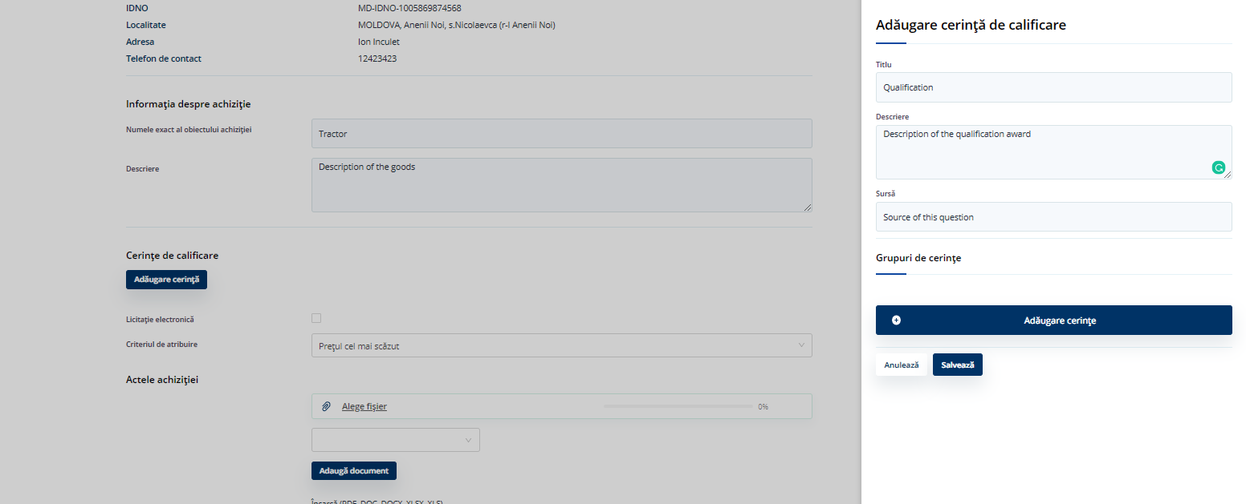

Figure 63. Create online tender – Add qualification requirements

It is also possible to add questions that will be used for the qualification. For each added question, a default response and desired answers can be defined. When the information is complete, the user must click on “Save”.

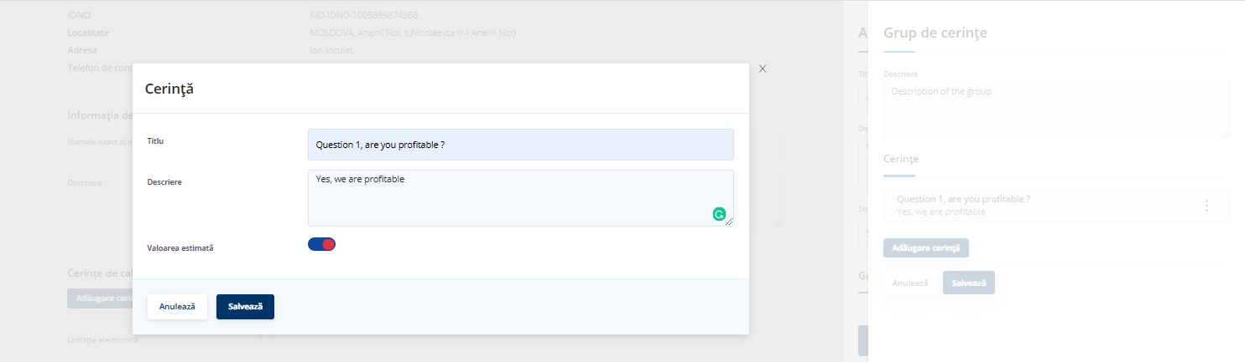

Figure 64. Create online tender – Add qualification questions

## Create Lots

Procurement procedures can be divided into lots, and each lot can contain a single or several items.

In order to create a lot, the user shall provide:

* Name of the lot;
* description of the lot;
* value, which cannot be higher than the amounts provided in the CA’s plan;
* contract period and address.

Once a lot is created, the user will be able to add items to it. In order to do so, the user shall click on “Add item” and:

* Provide a description of the item;
* select a CPV code from a predefined list;
* provide a quantity, unit and measure type for the item.



Figure 65. Create lots – Add items



Figure 66. Create lots – Selection of the CPV code

The selected CPV code is displayed next to the button:



Figure 67. Create lots – Description of the item



Figure 68. Create lots – Add quantity, units and measure type

Once all the items are added, the user must click on “Save”:



Figure 69. Create lots – Save the information

When the selected procurement method is not Price-Only, the system will display a step where the user will be required to provide awarding criteria:

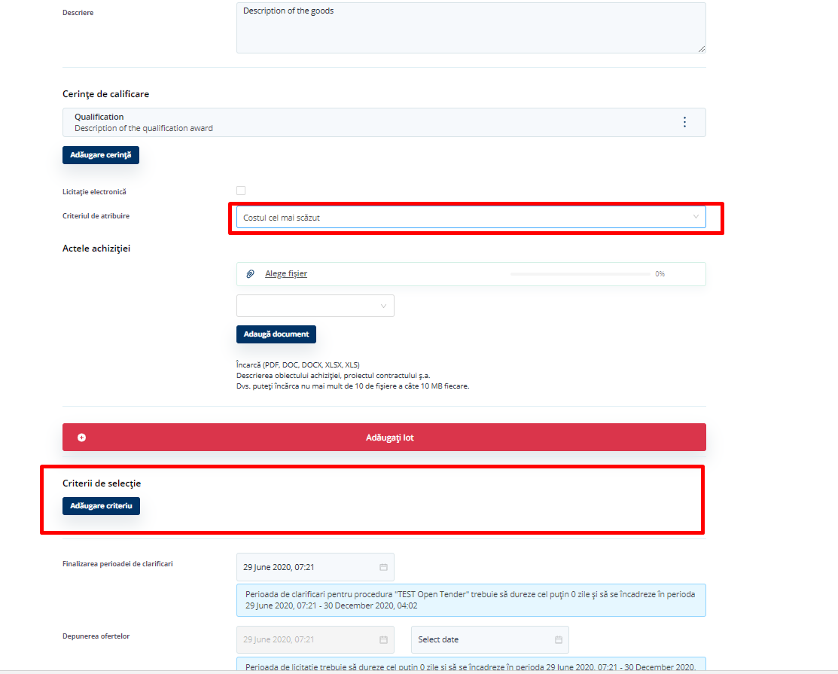

Figure 70. Create lots – Award criteria

A pop-up form will be displayed with the necessary information for the new criteria:

* Name of the criteria;
* description of the criteria;
* criteria source;
* lots for which the criteria apply.

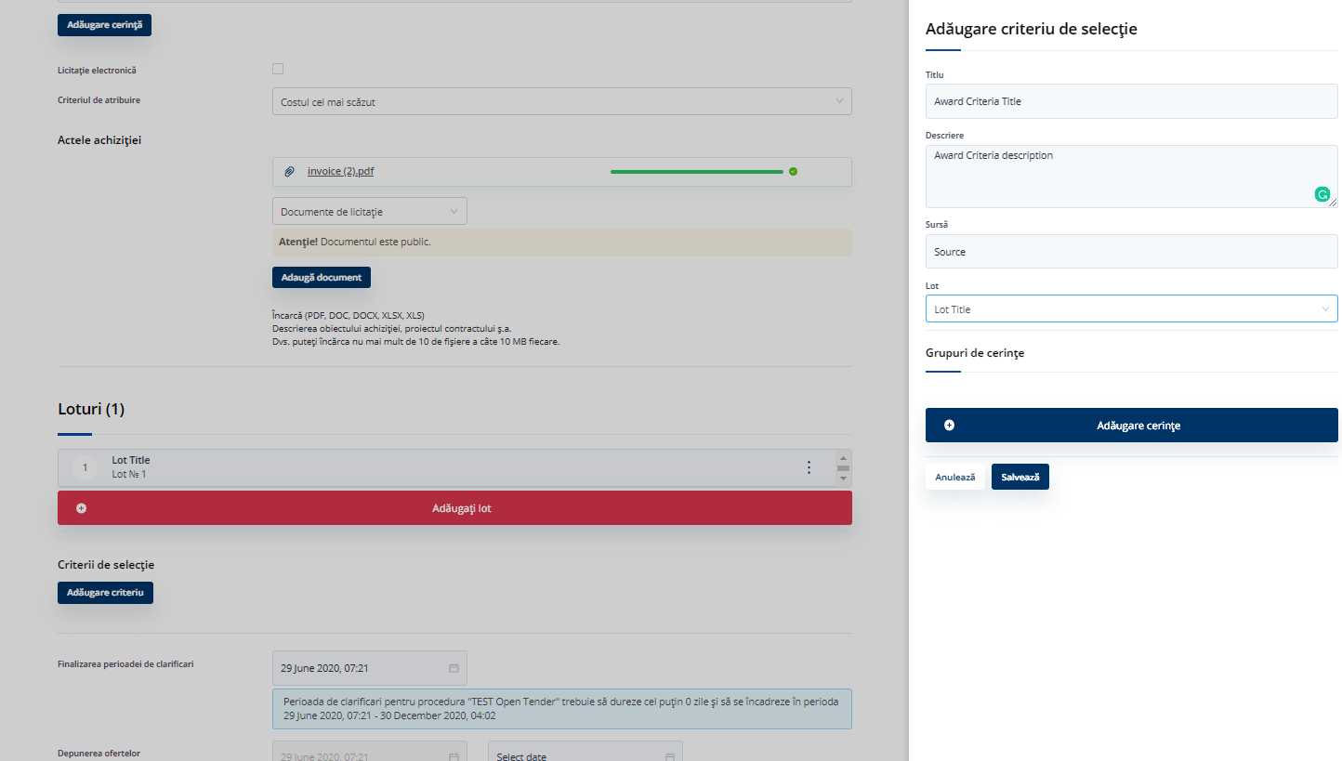

Figure 71. Create lots – Award criteria pop-up

The user will also be able to set questions related to the criteria, providing:

* Name of the question;
* answer;
* answer data-type from a predefined list;
* desired answer;
* name of the reason of the criteria and description of the reason;
* coefficient for answer conversion.

Once all questions are introduced, the user must click on “Save”.

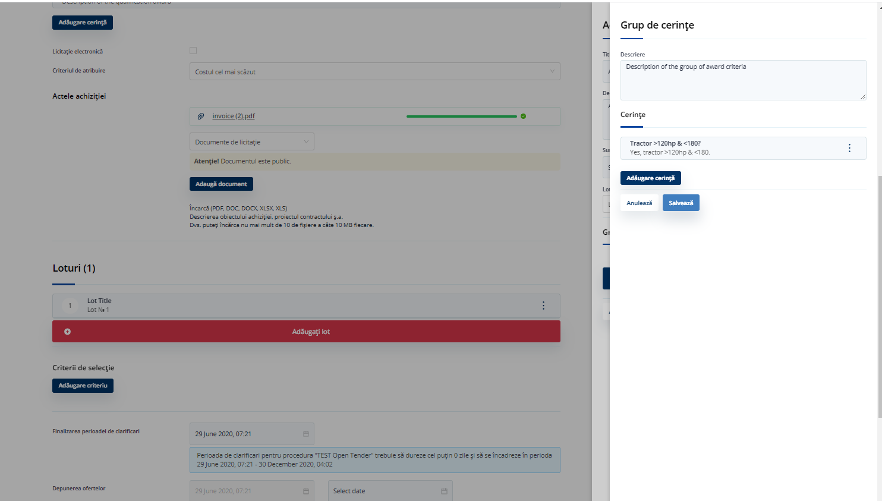

Figure 72. Create lots –Questions

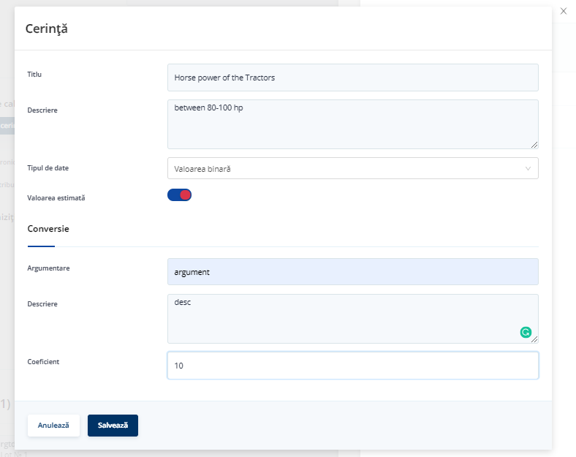

Figure 73. Create lots – Question

After saving, the introduced criteria and questions show on the Lot.

Finally, the user will be required to set the Clarification Period (only End of Clarification, since Start of Clarification will be the Tender Creation date) and the Period for the Reception of Bids (where the start date is set by default, equal to the End of Clarification). It must be taken into account that the minimum days for this periods depend on the procurement method (e.g. Open Tender – minimum Period of Clarification = 9 days, minimum Period of Tendering (receiving bids) = 11 days).

The form also contains a checkbox for conformity regarding Law No. 133/2011 on the protection of personal data.

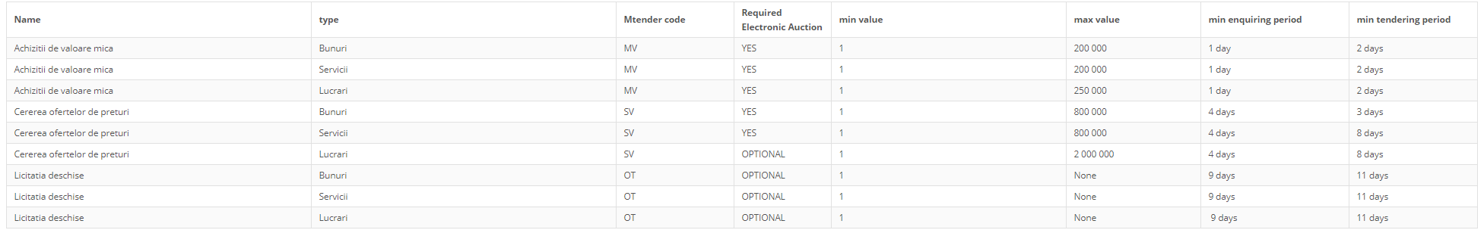

Figure 74. Create lot – Agreement with law

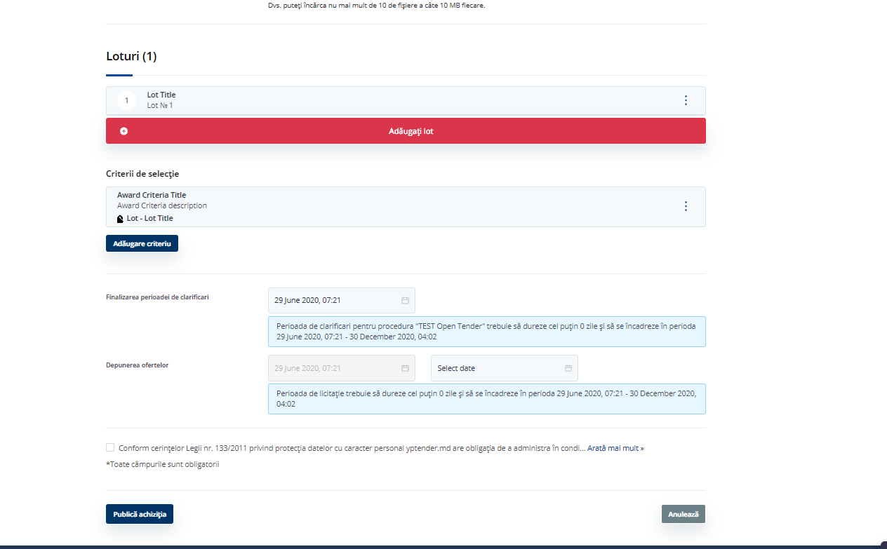

Figure 75. Create lot – Setting periods

## Bidding

Once the CA finalizes the aforementioned actions, the tender will appear in “My Tenders” list with status “Qualification period”.

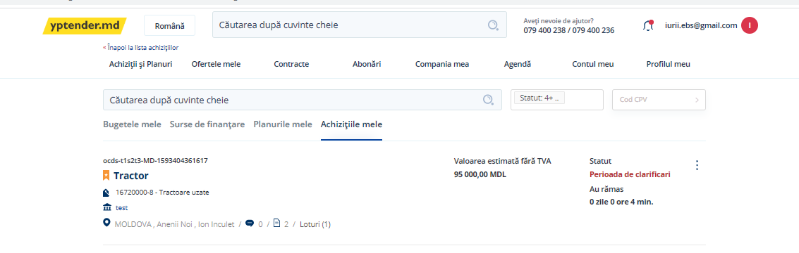

Figure 76. Bidding – “Qualification period” status in tenders list

From this moment on, EOs are able to consult the tender in the tenders list.

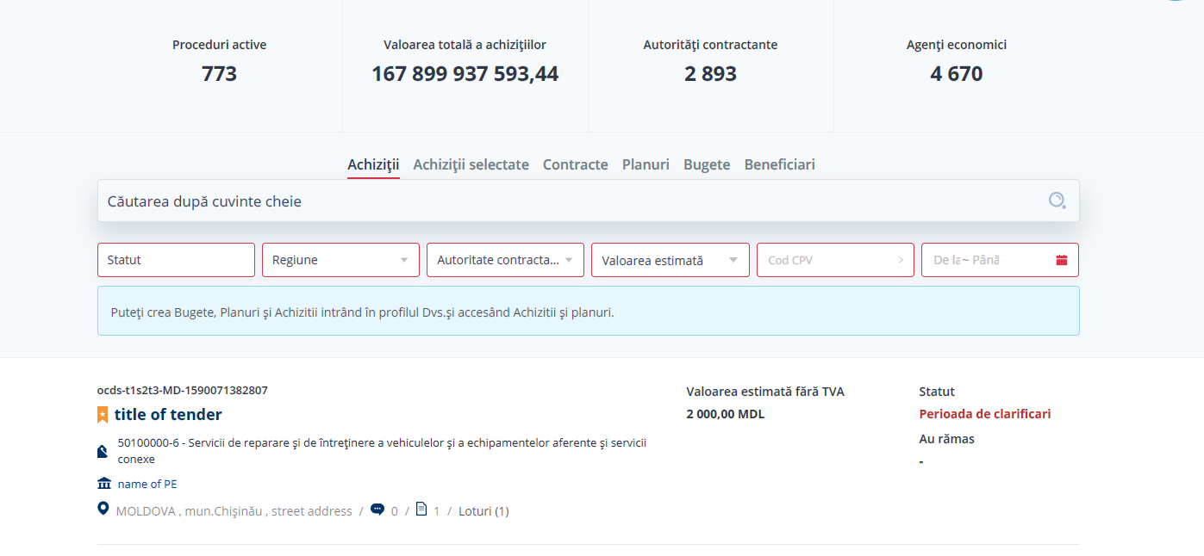

Figure 77. Bidding – Tenders list

During the Qualification Period, EOs have access to the detailed information of the tender.

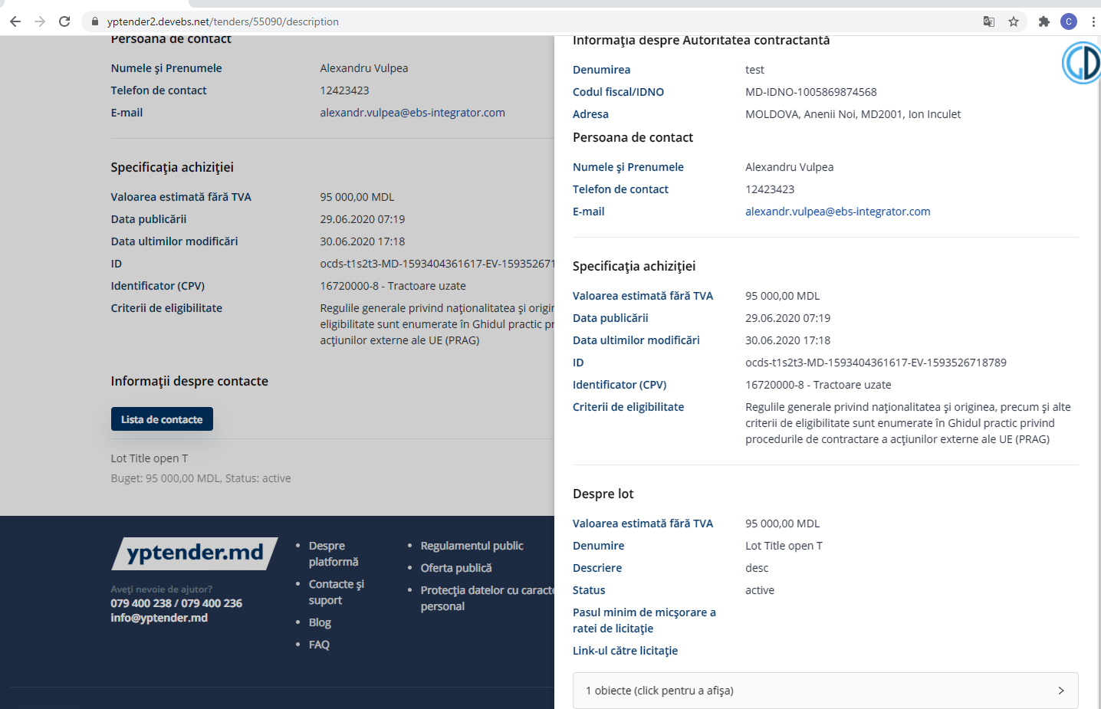

Figure 78. Bidding – Tender’s details

When the Qualification Period is over and the Tendering Period starts, EOs are able to submit their offers clicking on “Bid”.

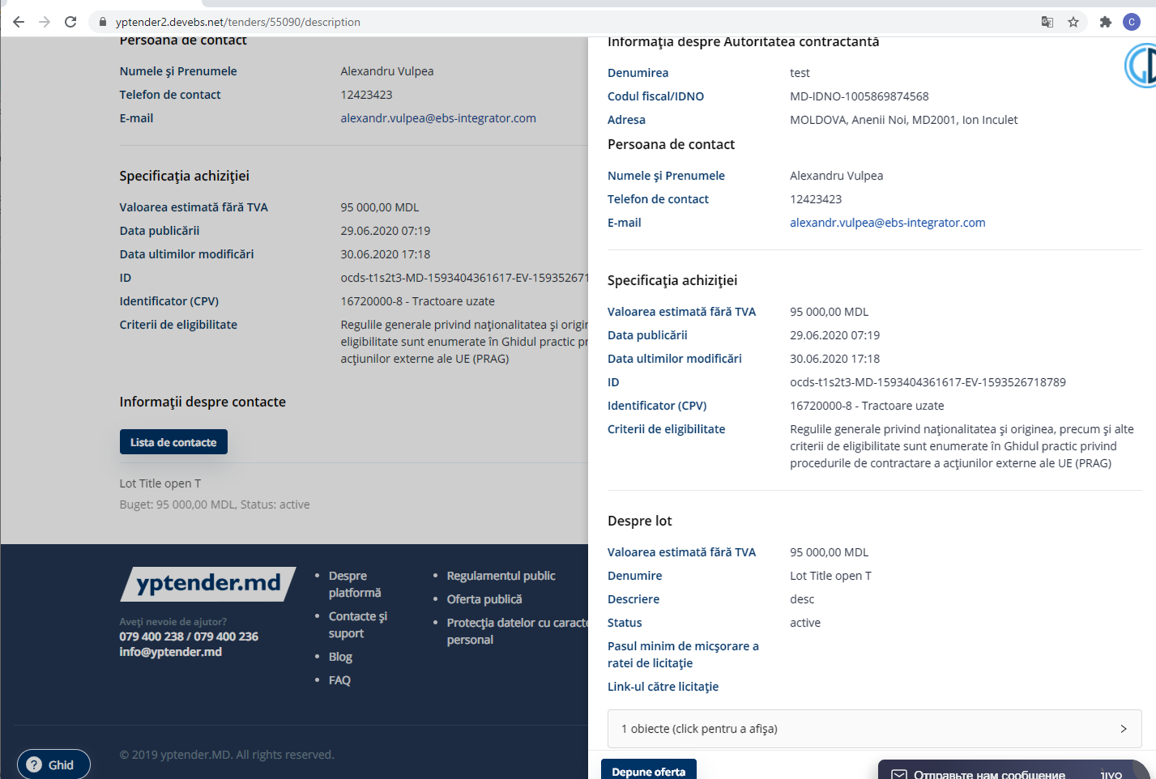

Figure 79. Bidding – Bidding button

In order to submit an offer, the EO needs to:

* Set the amount of the bid;
* add bidding document(s);
* provide an answer to Award Criteria questions required by the CA.

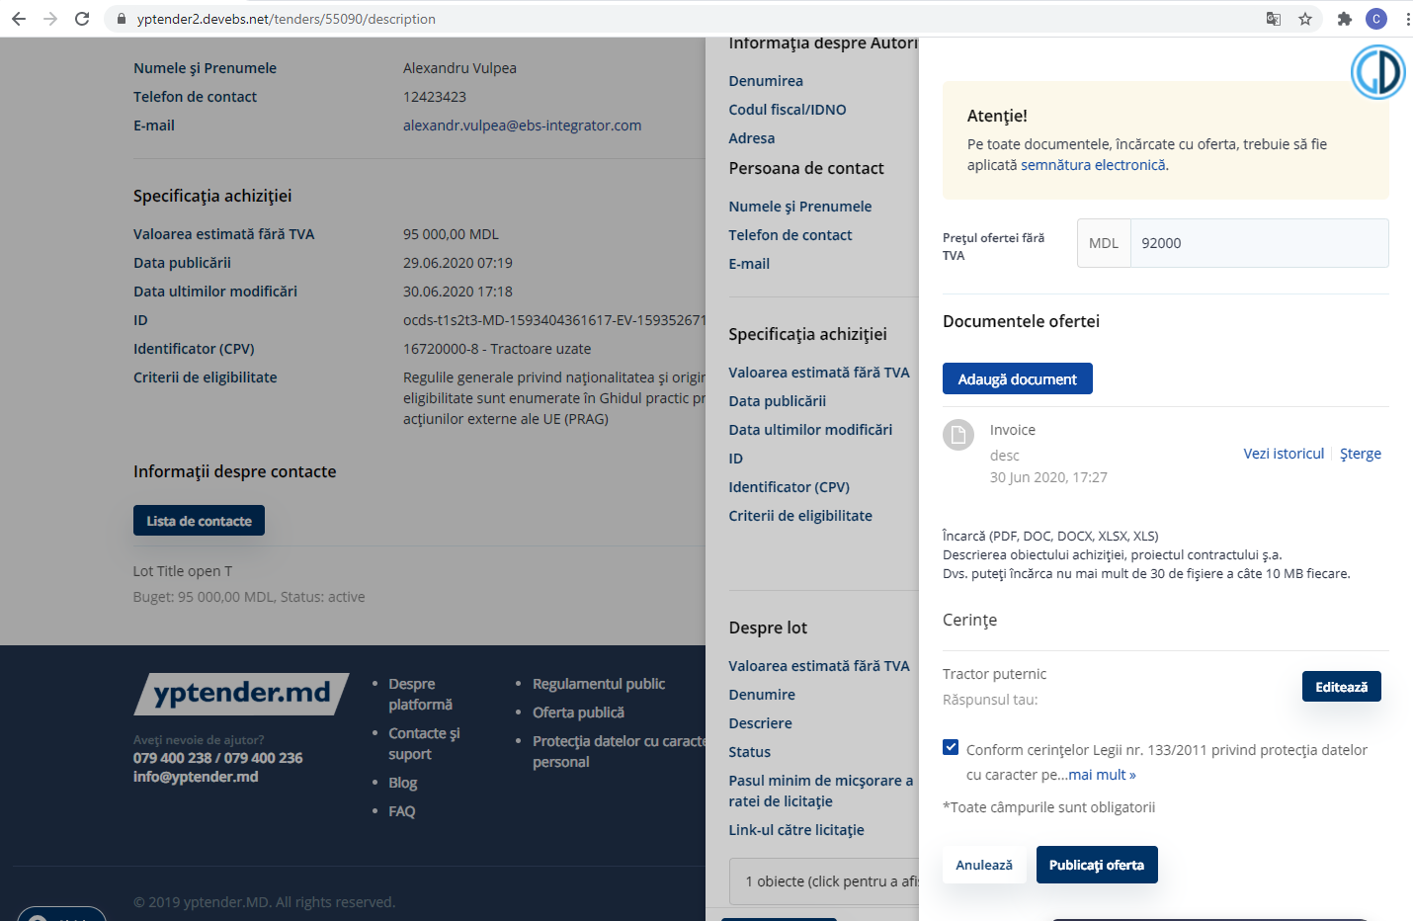

Figure 80. Bidding – Setting bid amount

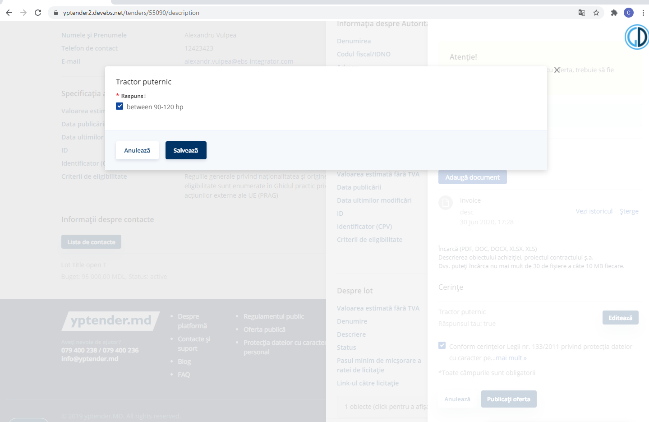

Figure 81. Bidding – Provide answers to award criteria questions

Before the submission of the bid, a pop-up with the details is displayed:

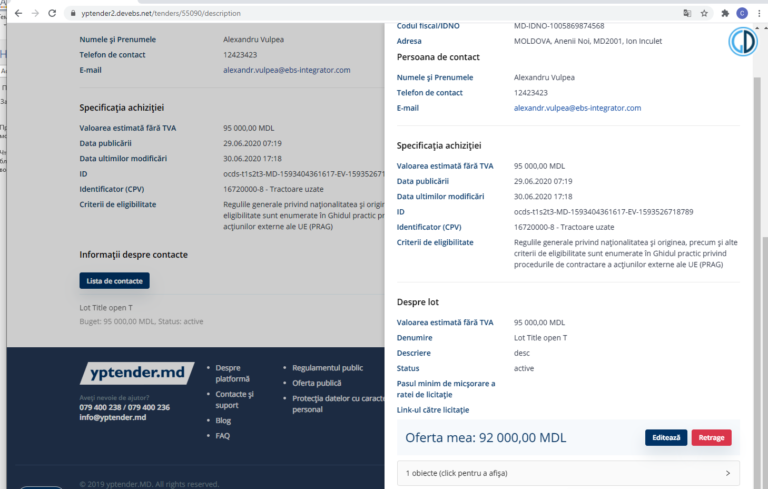

Figure 82. Bidding – Detailed information

The EO must click on “Publish” in order to submit the offer. Bidding functionality is available during the Tendering Period.

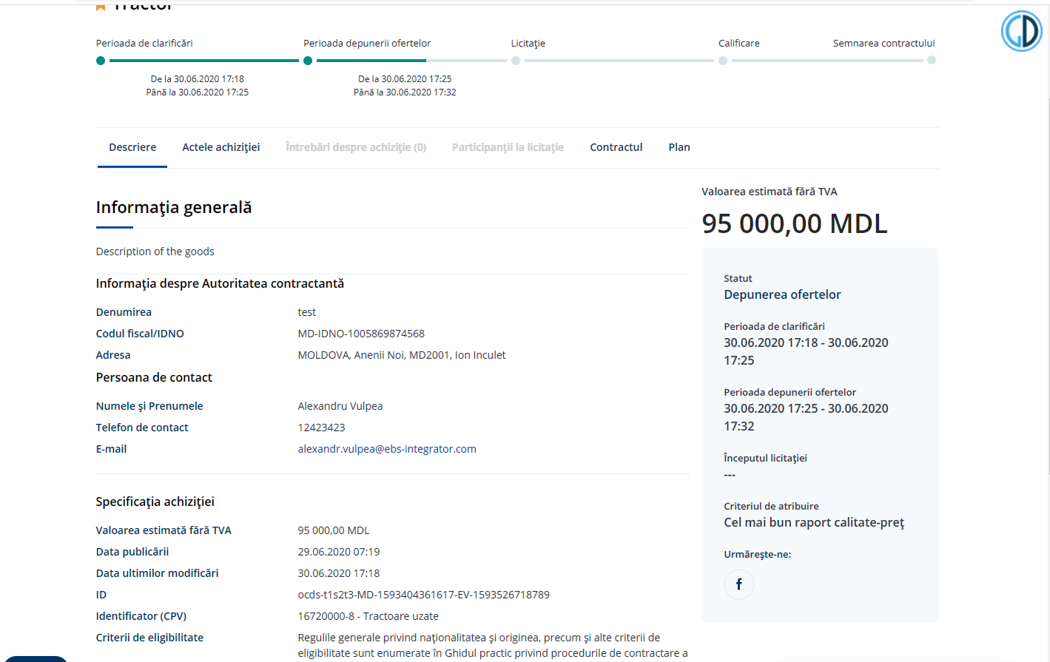

Figure 83. Bidding – Submitting (publishing) a bid

Once the Tendering Period is over, EOs are not able to submit offers and the tender status switches to “Qualification”.

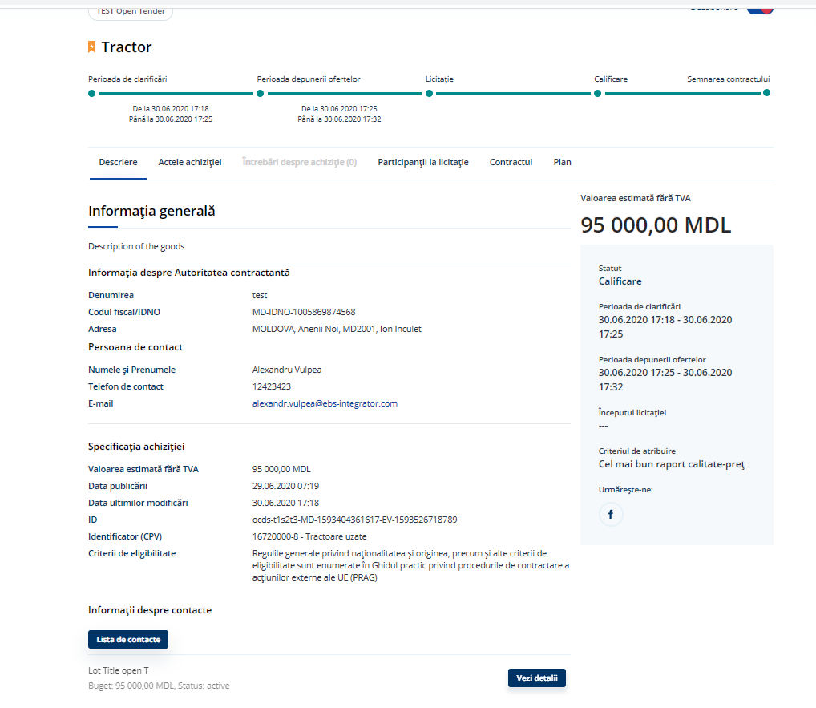

Figure 84. Bidding – changing tender status

* 1. Choosing the winner

Once the status of the tender is “Qualification”, the CA is able to select the winner.

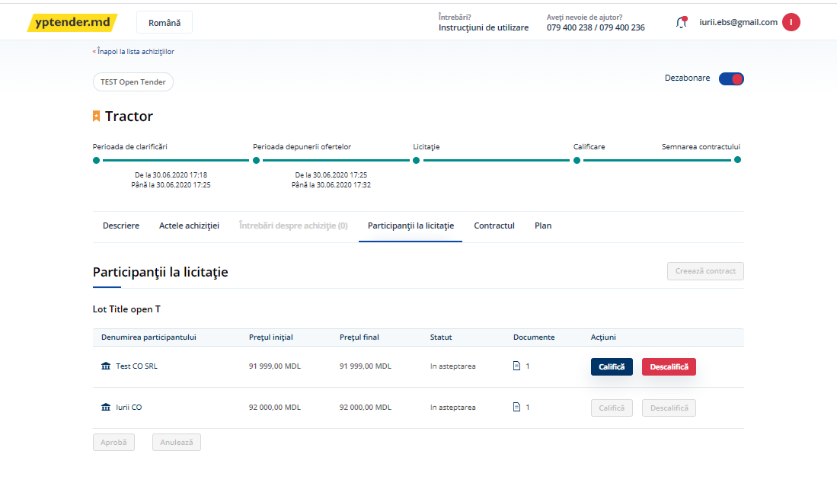

Figure 85. Choosing the winner – Tenderers list

When the procurement method is price-only, the winner is, by default, the tenderer with the best offer based on price; otherwise, with a procurement method where awarding criteria matter, the winner will be selected according to both the price and the answers provided by tenderers on Awarding Criteria.

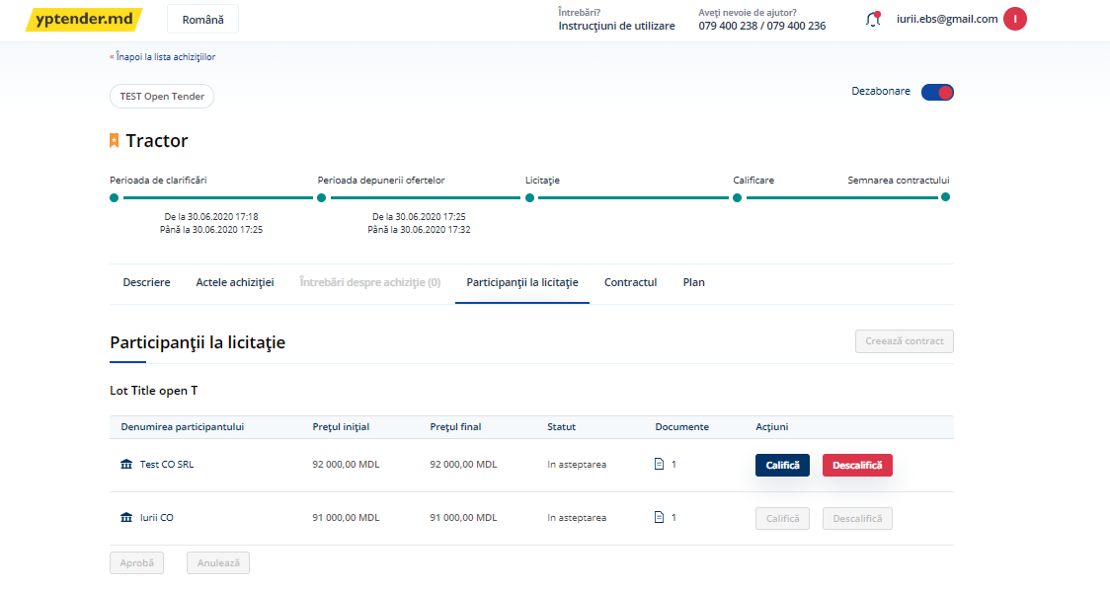

Figure 86. Choosing the winner – Setting the winner based on awarding criteria

Before selecting the winner, the CA can check the documentation uploaded by the EOs.

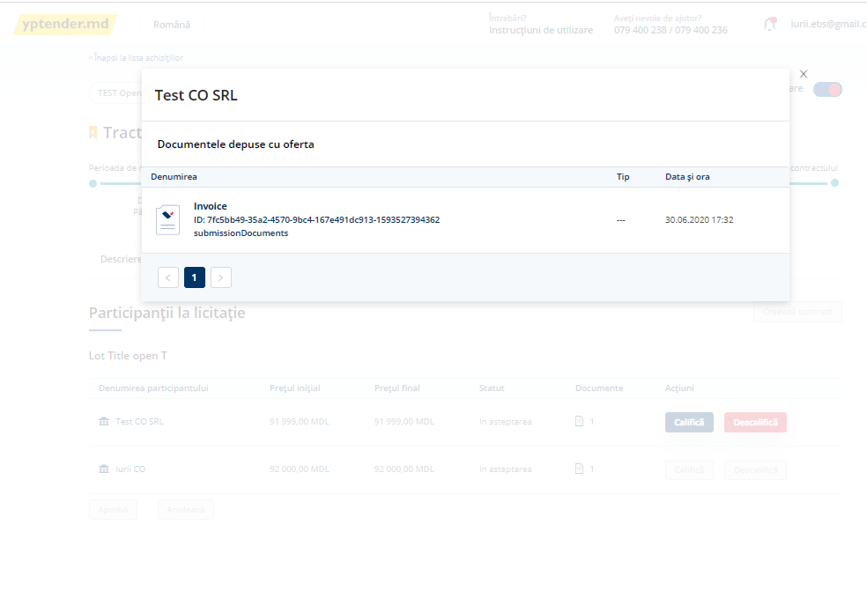

Figure 87. Choosing the winner – Revision of the documentation provided by tenderers

If the CA does not accept the first offer in the ranking as the winner, the CA will be able to disqualify it by clicking on “Cancel”: 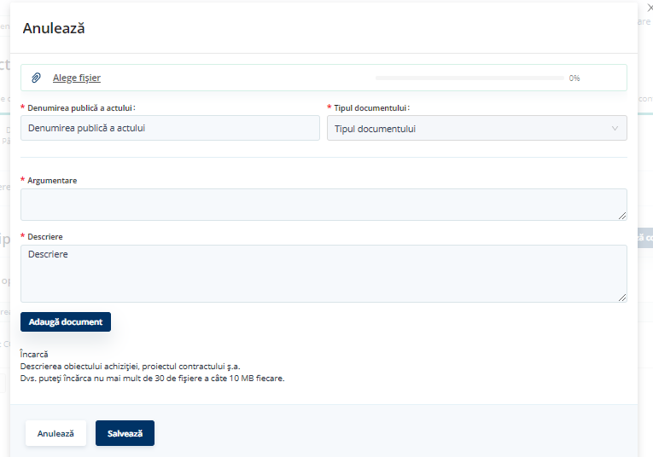

Figure 88. Choosing the winner – Disqualification of a tenderer

In order to select the winner, the CA shall click on “Qualify” and on “Approve”.

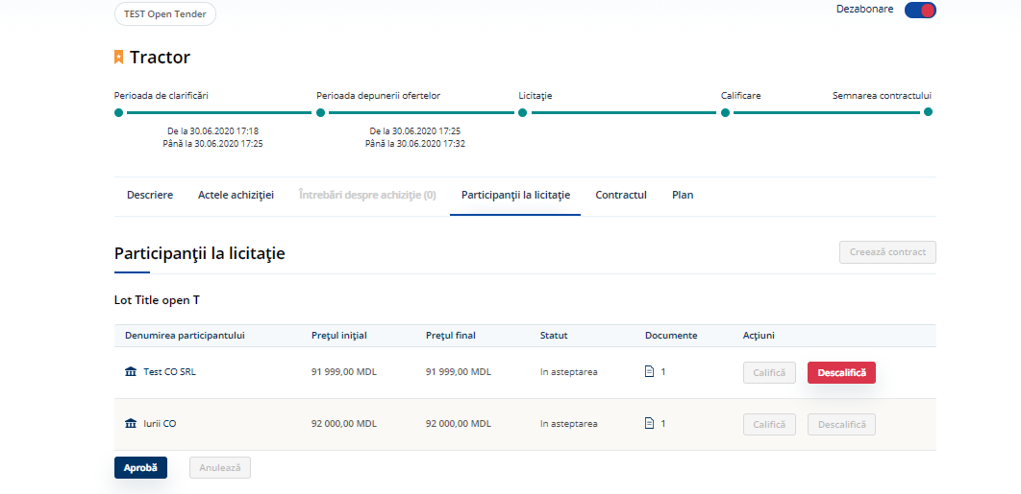

Figure 89. Choosing the winner – Selecting the winner

Once the winner is selected, functionality “Create contract” will be available.

(*NOTE:* Creation of the contract is not implemented).

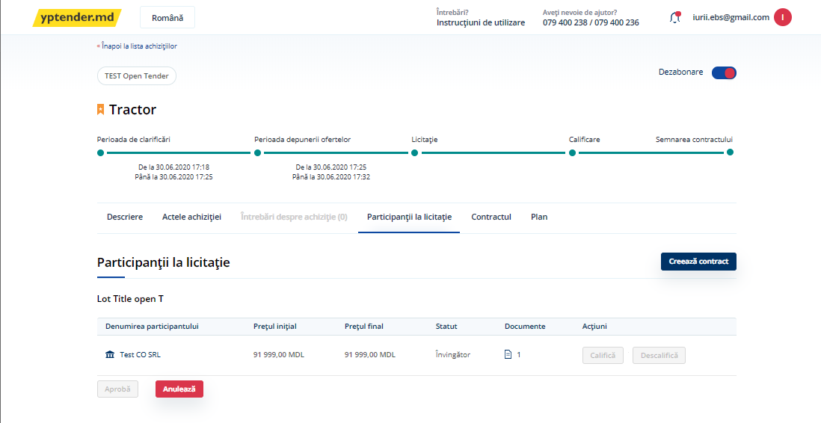

Figure 90. Choosing the winner – Creating the contract